

Southern California Edison
CS Re-Platform Project

CIM-CS-09-Manage Inbound Request
Customer Interaction Management
Business Process Design
Version 01.1

Table of Contents
1 Business Process Overview 5
1.1 Current Pain Points for Southern California Edison 5
1.2 Responsible Parties 5
1.3 Document Control 6
1.4 Terminology 6
2 Business Process Design 9
2.1 Channels of Inbound Correspondence 10
2.2 Viewing of Correspondence in Open Text 14
2.3 Handling of undelivered correspondence 16
2.4 Handling of Opt Out Request 20
2.5 Process / Performance Improvement 22
2.6 Prerequisites and Inputs 22
2.7 General Assumptions 22
2.8 Business Process Hierarchy 23
2.9 Process Flows 23
2.9.1 Upload Correspondence to Open Text 23
2.9.2 Handle opt out and undelivered correspondence 26
2.9.3 Viewing correspondence image 28
2.10 3rd Party and SCE Legacy System Integrations 29
2.11 Data Elements 30
2.11.1 Source Systems and Data Volumes 30
2.12 Cloud for Customer (C4C) Integration 30
2.12.1 Processes 30
2.12.2 C4C Views 30
2.12.3 Activity / BP Contact 30
2.13 Exception Management Requirements 30
2.14 Process Risks and Mitigation 31
2.15 Key Performance Indicators 31
2.15.1 Key Metric Definition 31
3 Controls, Regulatory Rules, and Security 32
3.1 Security Considerations 32
3.2 Custom Program/Transaction Codes 33
3.3 Custom Table/Transaction Codes 33
3.4 Data Criticality and Cybersecurity Baseline Risks 33
4 Technical Consideration 35
4.1 RICEF-W Assessment 35
4.1.1 Reports 35
4.1.2 Interfaces 35
4.1.3 Conversion 36
4.1.4 Enhancements 36
4.1.5 Forms 37
4.1.6 Workflows 37
4.2 IDEX Considerations 37
4.3 Production System Cut-over Considerations 38
4.4 Other Considerations 38
5 Change Management 39
6. Requirements 43
7. Appendix 44

This page intentionally left blank

Business Process Overview
This document defines the process in managing customer correspondence or responses that are received from the customer via various channels such as Email, US Mail, SMS, E-fax, Fax, Voice call and SCE.COM. When an inbound correspondence is received at SCE, the correspondence image will be stored in Open Text Extended Enterprise Content Management (xECM). Users are able to go to xECM to view, export, and re-print the correspondence image.
Whenever an inbound correspondence is uploaded to Open Text xECM, Open Text will create a BP Contact in S/4HANA automatically.
When a communication sent to a contact (BP or temporary contact in the case of a Trouble Order update) via email, voice, SMS or TTY is not successfully delivered, the system will automatically log the failure and failure reason in the system using BP Contact. This information will be available for viewing by users of the system and also available for the employee to query the reporting environment for this information (successful and unsuccessful delivery). If the delivery failure was the result of the phone or email address being inactive (e.g., bad device), the system will automatically delete the phone or email address on all BPs with the reason (e.g., bad device). User can view the deleted phone number along with the date and time in Hybris C4C Changes facet (see screen below).
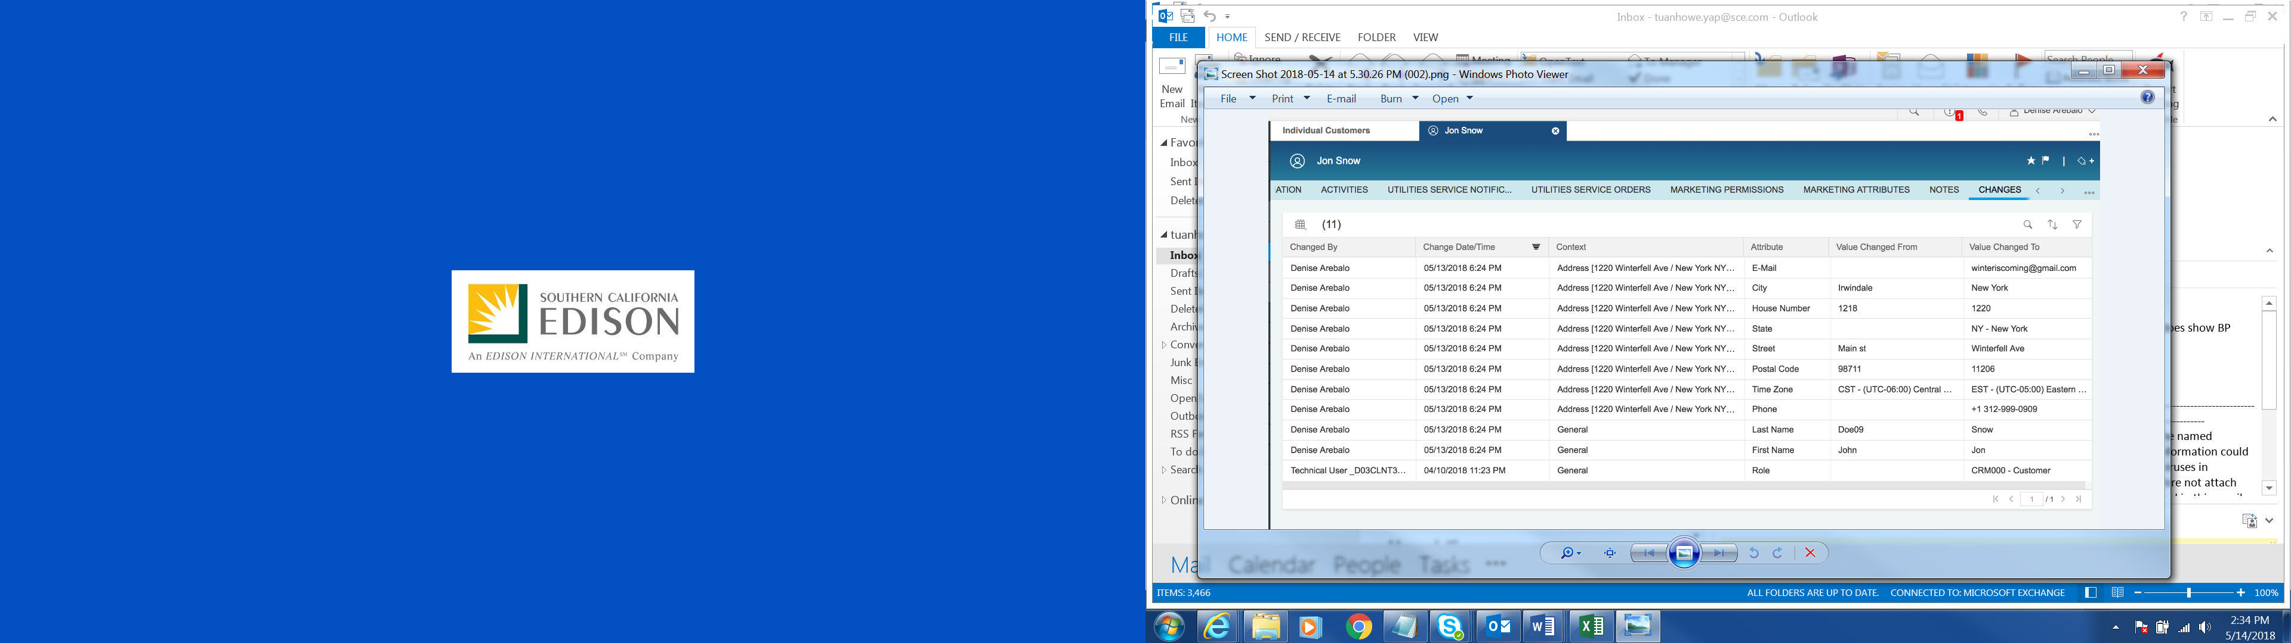
If a communication is delivered via U.S. mail and it is returned, a user will update the BP’s mailing address as required. These changes will be documented in Change History with the before and after data, date / time and user who made the update. The user will create a Ticket/BPEM to the appropriate department.
A customer can also send correspondence to SCE (e.g., text back STOP to a text message, mail us their completed program application, etc.). If the customer texted STOP for example, the system will automatically un-enroll the BP from that communication type and update BP contact with the reason (e.g., opt-out).

Current Pain Points for Southern California Edison
- We are not able to view what was sent the customer in the system today.
- Address exceptions only show up in CSS.
- Foreign address and US military addresses formatting issues are not being handled properly through CSS.
- Returned mail with bar code on envelope should go to the proper department and location and not all go to the central processing center.
- Returned mail is sometimes processed and customer records updated, however in many cases, nothing is done to update the source system to remove “bad” mailing address information.
- Issue often starts from planning department where premise city is put in as a non-standard city address (inconsistency between city/county boundaries vs. what is in the system).
- Mailing address can be mismatched between customer and service account levels.
- Users do not have visibility to know when the mailing address is bad so we can collect a new one when the customer calls
- Phone numbers in CSS are very out of date and there is not automated process to end-date the phone when a communication has failed.
- Enrollment in digital notifications is stored in many separate systems today and we are unable to ensure that we honor customer opt-out requests for different communication types
- Client Letter: Letter gets populated with customer level address, not account level address, resulting in returned mail.

Responsible Parties
Contact | Contact Person
Southern California Edison Business Process Owner | Janet Covington
Southern California Edison Lead | Christine Evans
HCL Functional Lead | Adrianus Halim
Solution Architect | Pedro Costa
Front Office Lead | Christine Evans
Subject Matter Experts | Janine Aumont  Scott Hirth  Debbie Tillman  Lorena Carrasco  Natalie Martinez  Frank Starke
Key User Group | Customer Contact Center (CCC)  Business Customer Division (BCD)

Document Control
Version | Description of Change | Date | Author
0.1 | Creation of Initial Version | 02/09/2018 | Satyendra Singh
0.2 | Review | 03/14/2018 | Tuan Howe Yap
0.3 | Updated after Review Comments | 03/18/2018 | Satyendra Singh
0.4 | Review | 03/22/2018 | Tuan Howe Yap
0.5 | Updated after additional information and Review | 03/27/2018 | Satyendra Singh
0.6 | Update | 04/02/2018 | Tuan Howe Yap
0.7 | Update based on review from Shalini | 04/18/2018 | Tuan Howe Yap
0.8 | Update based on review from Pedro | 04/20/2018 | Tuan Howe Yap
0.9 | Update based on review from Pedro | 04/23/2018 | Tuan Howe Yap
0.10 | Update based on review from Lee | 04/27/2018 | Tuan Howe Yap
0.11 | Update based on review from Lee | 04/30/2018 | Tuan Howe Yap
Final 1.1 | Remove RICEFW to FOP & RICEFW | 10/09/2018 | Tuan Howe Yap

Terminology
Term or Acronym | Description of Term or Acronym used in this Document
APSE | Accelerated (or Axon) Project Support Environment
BDEX | SAP add-on functionality to support the processing of BPEM Cases
Billing Cycle | Is a group of contracts to be billed together via date-driven or regional criteria, it controls the billing cycle and is linked to the Meter Reading Unit. SAP equivalent term is the Portion.
Billing Document | A document that outlines the charges incurred for energy consumption for a specific contract. During the process of Billing, a billing document is generated for each contract on a contract account.
BMD | Business Master Data. The customer information which includes personal details, payment terms, dunning levels, billing rates and rate categories. The business master data objects are Business Partner, Business Agreement/Contract Account and Contract.
BPD | Business Process Design (or Document)
BPEM | Business Process Exception Management
BP Contact | This is a transaction in S/4HANA to document an interaction with a customer. It is NOT the creation of a Business Partner.
BWR | Basic Work Request. SAP equivalent is BPEM.
CA | Contract Account
Channel | Data object in SAP that holds the interval data. Intervals can be kwh, price, factor, etc. SAP equivalent is Profile.
Clarification | A list of payments that could not be processed and require additional work in order to be posted.
Connection Object | Link between installation and postal regional structure. Usually a building, but can also be a piece of property or other facility, such as a fountain or construction site. The connection object corresponds to the functional location in plant maintenance (PM).
Contract | Standard SAP object that is used to link SAP Business Master Data and Technical Master Data through the move-in process
Customer | Any entity with a relationship with SCE. This term is usually used in reference to customers (both individuals and organizations) This can include employees and third party suppliers (banks and payment partners). SAP Equivalent is Business Partner (BP)
FERA | Federal Emergency Relief Administration
HEER | Home Energy Efficient Program
Hybris C4C | SAP Cloud for Customer Solution
IMG | SAP Implementation Guide – where configuration is performed
Level Pay Plans | SAP equivalent term is Budget Billing. Budget Billing allows customers to pay regular equal amounts over a yearly period.
MBL | Medical Baseline
Premise | Represents one of the SAP Technical Master Data object that is supplied with energy, for example, an apartment or factory. A premise can have several utility installations. The premise is allocated to a connection object and the address of that connection object
Property | Standard SAP object that is primarily used for arranging agreements with the owner concerning automatic move-in. It also stores an owner history for installations that are part of owner allocation process
S/4HANA | SAP HANA 4 Business Suite
SCE | Southern California Edison
Summary Billing | Standard SAP functionality that enables the invoicing of multiple Contract Accounts under one Parent Contract Account (Consolidated Summary Billing). SAP equivalent is Collective Billing.
TCODE | Transaction Code Description
TMD | SAP Technical Master Data e.g. Connection Object, Premise and Device Location
xECM | Extended Enterprise Content Management
Additional terms may be found in APSE General Document # 32 CSRP Glossary

Business Process Design
Inbound correspondence is correspondence that customer sent to SCE via various communication channels such as email, voice, SMS, TTY e-Fax, Fax, and US mail.
Examples of inbound correspondence can be any of the following:
- Application form for P&P such as HEER, CARE, FERA, MBL etc.
- Supporting documents from customer that were requested by SCE
- Customer responses from an outbound correspondence from SCE such as opt-out request (e.g., text STOP), reply to notification (e.g., power is still out), a completed application, etc.
- Undelivered voice, email, SMS, TTY or return US mail
Below is a high level diagram of the lifecycle in handling inbound correspondence and the integration between Open Text and various systems. The step numbers are referenced in the diagram (Figure 1). This diagram is for scenarios where customer is responding to an outbound notification that is sent by SCE via US mail, SMS and email.
It begins with the customer sending correspondence to SCE via various communication channels such as U.S. mail (1), SMS & email (2) and SCE.Com (3). If the correspondence is sent to SCE via U.S. mail, user will scan the correspondence using Kofax or MFM (Multi-function Scanning Machine) (4). Kofax is an application that scans hardcopy correspondence and generates softcopy that can be uploaded into Document Repository System such as Open Text Extended ECM (xECM). A softcopy of the scanned correspondence is stored in Kofax. Once the correspondence is ready to be uploaded to xECM, user can use Kofax to index the correspondence with customer information (metadata) such as Contract number, correspondence name and channel received. Users that use MFM will scan the correspondence and email the softcopy of the correspondence to themselves. They will then attach the correspondence to xECM using MS Outlook. User will also need to ensure the document is labeled so it can be easily identified when a user is looking through various correspondence for the BP.
A copy of the email is uploaded to xECM manually by user via MS Outlook while SMS is indexed and uploaded to xECM automatically (5). A copy of the correspondence is then stored in xECM. Correspondence from SCE.COM is integrated with xECM directly and correspondence image is indexed with metadata automatically. Front Office user is able to view the correspondence image via Hybris C4C (6). A BP Contact is created automatically in S/4HANA by Open Text for every inbound correspondence that uploaded to xECM using enhancement E-CIM-CS-11 - Auto IR creation for Inbound & Outbound Correspondence/Communication. Outbound correspondence activity will be documented in BPD CIM-CS-11 Handle Outbound Request.
If the user does not have access to KOFAX, the user will utilize a MFM (multi-function scan machine) in place of KOFAX to scan and email the document to themselves. The user will need to enter the metadata for the document when uploaded to xECM using MS Outlook. A softcopy of the scanned correspondence is stored in the MFM.
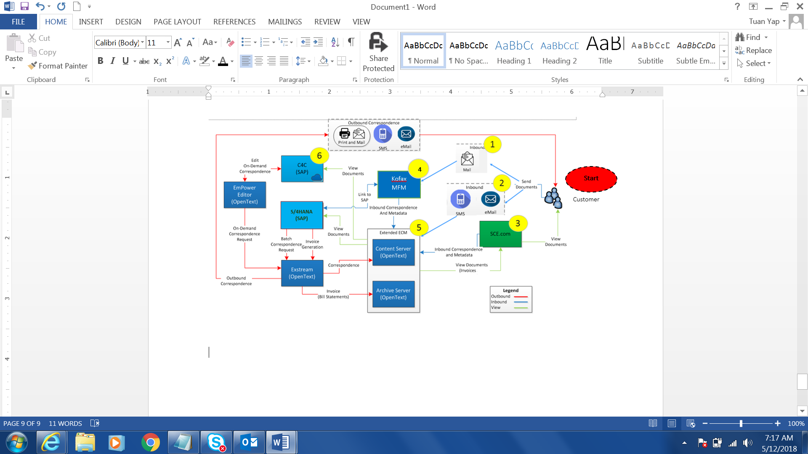
Figure 1: Inbound & Outbound Correspondences process

Channels of Inbound Correspondence
SCE receives correspondences from customer via US mail, email, eFax, Fax, SMS, TTY and SCE.COM. An image of the correspondence will be tagged with metadata via Kofax or MS Outlook. Users that do not have access to Kofax will use a MFM (multi-function scanning machine) to scan the correspondence and email the soft copy to their email inbox. An image of the correspondence is then uploaded to Open Text Extended Enterprise Content Management (xECM) for user to view.
A BP Contact will be created by xECM automatically when a correspondence is uploaded. The BP Contact will have the following information:
- BP name & number
- Class - ‘Inbound Correspondence’
- Action - ‘Uploaded to xECM’
- Type – Channel correspondence is received. It can be ‘Email’, ‘US Mail’, ‘SMS’, ‘Phone’.
- In/Outgoing – ‘Incoming’
- Date/Time – System date/time
- Long Text – Name and ID of the correspondence.

The process of handling inbound correspondence via different channels are documented in this section below.
Storing US mail using Kofax to scan
When SCE receives inbound correspondence that is in paper form, user will scan the correspondence using Kofax. This activity is called Create Batch.
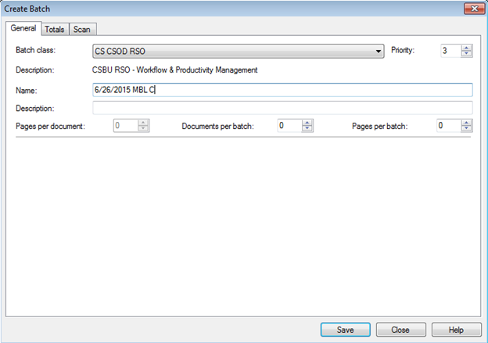
Figure 2: Kofax Create Batch

The scanned US mail image is kept in Kofax. User can view the list of scanned correspondence images that is ready to be uploaded to xECM (Figure 3).
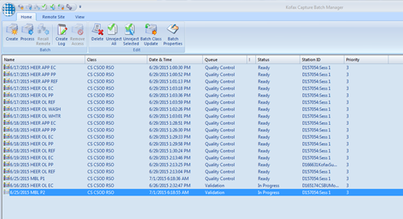
Figure 3: Kofax scanning

User retrieves the scanned correspondence image from Kofax and enters the metadata to index the correspondence (Figure 4). Metadata is predefined in Kofax for each type of correspondence such as Contract number, Program (i.e. MBL, CARE, FERA and HEER), and Category (i.e. Part 1 or Part 2. Applicable for MBL only), Applicable Received Date, Applicable Submit Method, Customer email and Batch date. Currently, Kofax only uses Contract number as the metadata. HCL proposes Kofax to offer BP number and Contract Account number as optional metadata in addition to Contract number. This requires enhancement to Kofax.
Before the user enters the Contract number as a metadata, the user will need to verify the Contract number manually by navigating out of Kofax into S/4HANA. The user will submit the correspondence image once it is ready to be uploaded to xECM. There is an interface enhancement required for Kofax to link to xECM using I-CIM-CS-09 Interface between Kofax and OpenText xECM. If a user does not have access to Kofax, they will need to scan the document using MFM and email it to themselves, then they can upload the document to xECM.
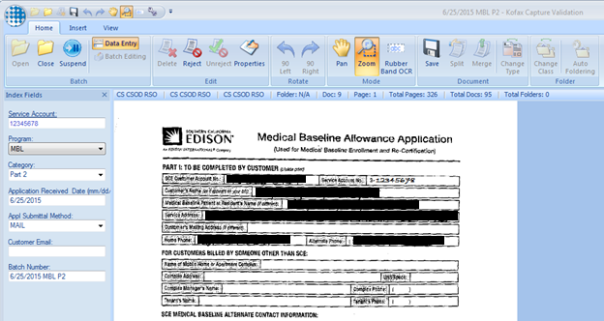
Figure 4: Indexing correspondence in Kofax

When a copy of correspondence is uploaded to xECM, the correspondence will be linked to the SAP Object such as BP, Contract Account, or Contract by xECM based on the metadata entered (i.e. Contract number) in Kofax.
If the receipt of the correspondence requires additional action (e.g., process the program application received) and another user needs to be notified, the system shall create a BPEM case in S/4HANA by xECM automatically using workflow W-CIM-CS-09 Inbound Correspondence BPEM auto creation. The BPEM case contains an attachment which is the correspondence image that was indexed using Kofax. The BPEM case would be created having the metadata object reference such as BP number and Contract number.
If the correspondence is related to SDP, HEER, MBL, CARE or FERA, the BPEM Case category such as ‘SDP Application’, ‘MBL Application’, ‘Income Qualified Program’ (for Care & FERA). The BPEM will be routed to different team to work on as there are different processes to handle these applications. Refer to BPD PP-CS-02 - Program Enrollment and Delivery, De-Enrollment & Decommission Programs for detail information about the process.
User will then attend to the BPEM case using BDEx report. Once BPEM case is located, user can select the line item from BPEM case (Figure 5) to view the correspondence image.
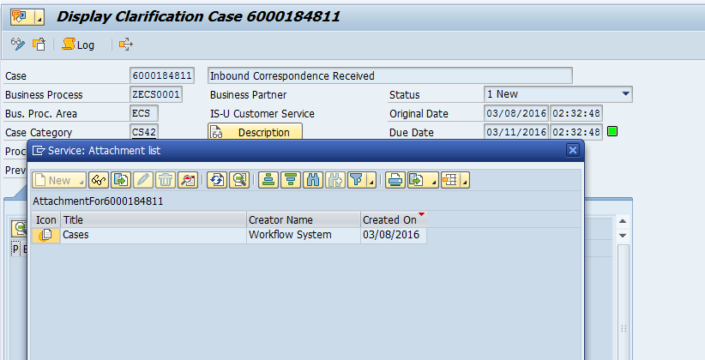
Figure 5: BPEM attachment list

A BP Contact will be created by xECM automatically when there is a correspondence uploaded to xECM Content server. This is done using enhancement E-CIM-CS-11 - Auto IR creation for Inbound & Outbound Correspondence/Communication.

Storing of Email
CCC (for example, email id SCE-OLS@sce.com and CICORR@sce.com) and BCD users currently receive email. xECM is integrated with SCE MS Outlook (Figure 6). An Interface (Enterprise Connect) is required between MS Outlook and Open Text which allows user to enter the metadata and upload the email to xECM using I-CIM-CS-09 – Interface between MS Outlook and OpenText xECM. A copy of the email will be linked to the SAP object such as BP, Contract Account, or Contract automatically by xECM based on the metadata. A BP Contact will be created by xECM automatically when the document is uploaded to xECM.
User is able to upload an email to xECM in an email file format or upload a document to xECM in PDF or MS Word format. The filename that will be shown in xECM is the same filename of the document that uploaded. If a user needs to re-name a document it must be re-named before being uploaded to xECM.
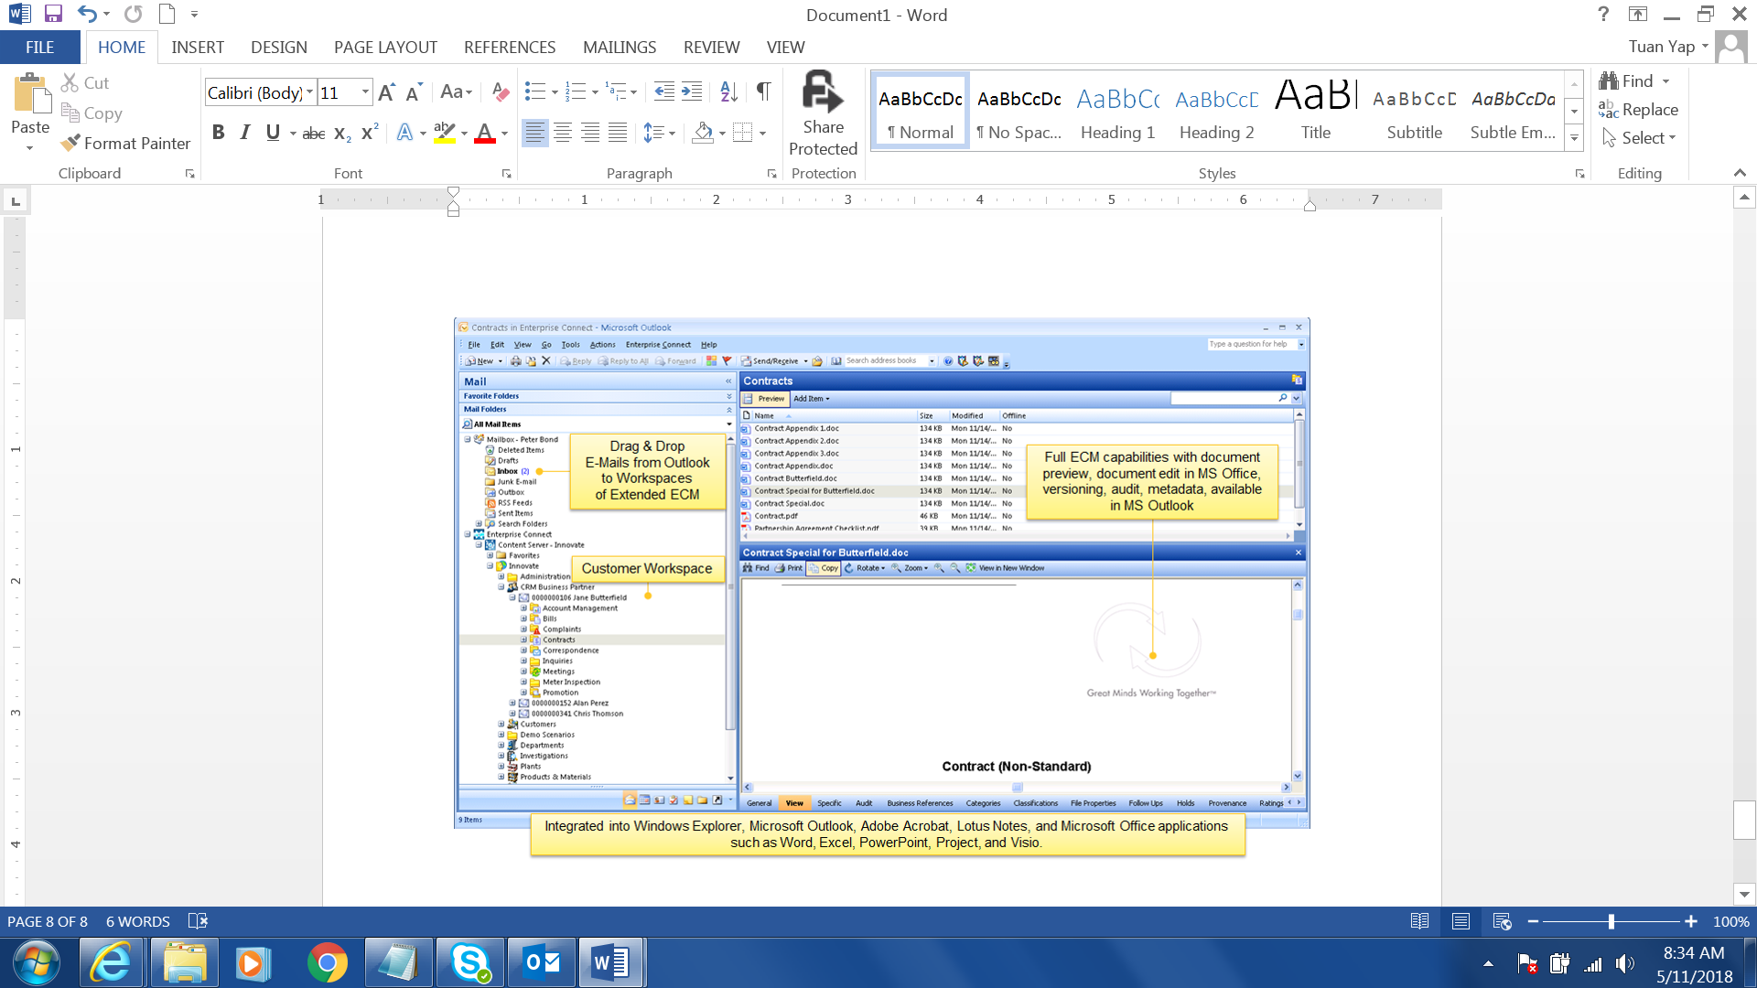
Figure 6: MS Outlook with xECM add on

Storing of email, SMS, TTY, Voice Call
The customer may reply to an SCE digital communication (email, SMS, voice call, or TTY) to opt-out or just to reply to the message with a question or comment. Digital communications will be sent to customers using a 3rd party notification system via Open Text Exstream (Communication Server). If a customer responds to an email, SMS, voice call, or TTY message, the 3rd party notification system will provide the response in a file and it will be uploaded to a file server. The S/4HANA program will upload the file to xECM and update the response from customer according using E-CIM-CS-09- Update contact detail as bad and update with a reason.
Responses from customers can be opt out of SMS correspondence. Refer to section 2.4 for process in handling Opt Out.
Customer can also request to sign up for program, recertification and verification using SMS. Refer to PP-CS-02 - Program Enrollment and Delivery, De-Enrollment & Decommission Programs for detail process in handling these requests.
An acknowledgement notification will be sent to customer by Open Text using a standard SMS reply content defined by SCE to inform customer that SCE received the SMS using enhancement E-CIM-CS-09- Send automatic outbound acknowledgement. A copy of the acknowledgement notification to customer will not be stored in xECM.
BP Contacts will be created by xECM automatically whenever a correspondence is stored in xECM using E-CIM-CS-11 - Auto IR creation for Inbound & Outbound Correspondence/Communication.

Viewing of Correspondence in Open Text
Correspondence image stored in xECM can be viewed via Open Text Content Management view in Hybris C4C and S/4HANA. These screens provide 360 degree view of all the correspondence for a particular BP. These screens are Open Text application within SAP that allows a customized view of hosting correspondence image files.
The filename of the correspondence image cannot be renamed once the file is created in xECM. The file will show the time and date stamped. The file can be copied, moved, deleted, and send for re-print.

Front Office view
Front office user will view the correspondence image in Open Text xECM web portal via Hybris C4C mashup. After locating the BP in Hybris C4C, Hybris C4C will pass the BP number to the xECM screen (Figure 7) when navigating to the mashup view and the correspondence images related to the BP will be shown in xECM screen.
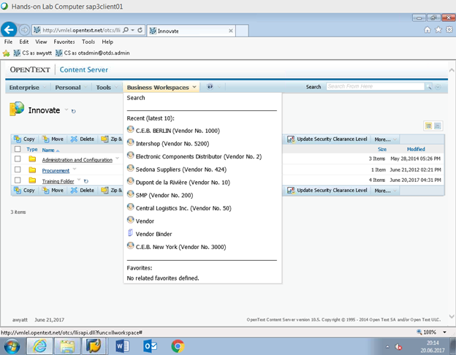
Figure 7: xECM web portal

xECM contains Business Workspaces and each Business Workspace can contains multiple folders. Business Workspace is like a Directory and folders are mainly to break down the storing areas for further classification. There will be 3 Business Workspaces configured and they are below:
  - 1st Business Workspace is called ‘Correspondence’. This is to host regular inbound and outbound correspondences. The correspondence uploaded will be labeled accordingly. Inbound correspondence will have ‘IN’ appended as prefix followed by the original filename. Outbound correspondence will have ‘OB’ appended as prefix followed by the original filename.
If the BP calls to enquire about an outbound correspondence that BP received, user can focus on the list of correspondence images having a filename with prefix ‘OB’.
  - 2nd Business Workspace is called ‘Bill Statement’. This is to host Bill Statements that are sent to the BP. 2 folders will be created and they are:
    - ‘Bills’. This folder will host bills created by S/4HANA
    - ‘Legacy Bills’. This folder will host bills migrated from legacy system (Open Text)

  - 3rd Business Workspace is called ‘Confidential’. This is to host confidential correspondences. Any document uploaded to this Workspace can only be viewable by authorized user. Unauthorized user will not be able to navigate into this Workspace. As the authorization is control at the Business Workspace level, SCE can define multiple Confidential Business Workspaces based on the required correspondence type such as ‘Confidential – MBL’, Confidential – CARE’.
Once the user has navigated to the folder and located the file, user will double click on the file to view the document image (Figure 8).
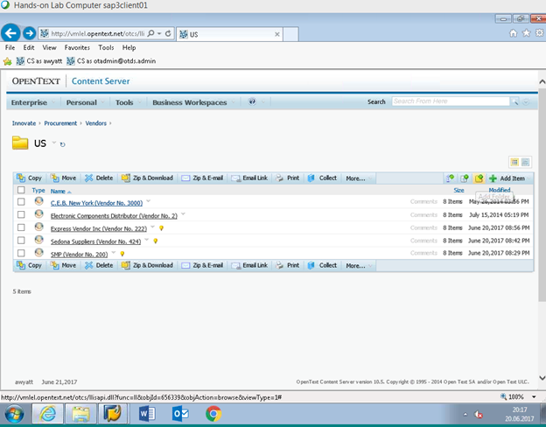
Figure 8: xECM web portal files

Back Office view
Back Office user can retrieve the correspondence image via any transaction in S/4HANA. User can go to any transaction and select ‘Extended ECM Business Content’ option from the drop down menu (Figure 9).
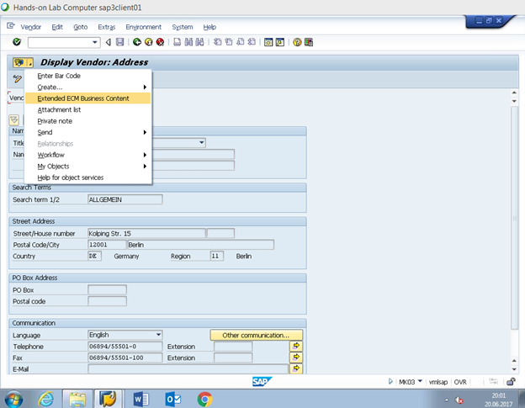
Figure 9: S/4HANA xECM

The BP number will be passed from S/4HANA screen to xECM Business Workspace screen automatically where all correspondence for the BP will be shown on the screen. The Business Workspaces and Folders will be the same as defined in Hybris C4C xECM view. Once the file is located, user will double click on the file (Figure 10) to view the correspondence image.
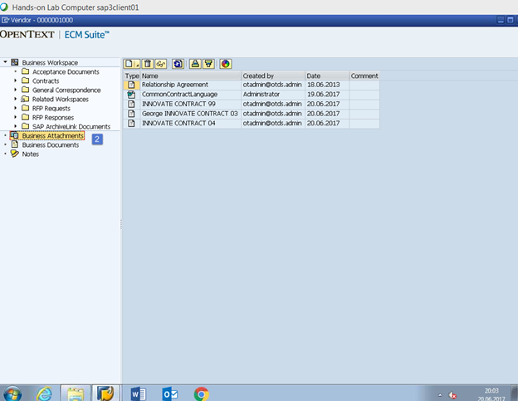
Figure 10: S/4HANA xECM files

Invoices
A copy of the invoice/bill will be stored in Open Text view and is viewable via SCE.COM, Hybris C4C xECM Mash up (Figure 8) and S/4HANA (Figure 9), Hybris C4C Invoice number hyperlink under Utilities Financial option (Figure 11) and Open Text view in Hybris C4C. Refer to BPD UB-BI-09 - Produce Invoice - Invoice Print for more information.
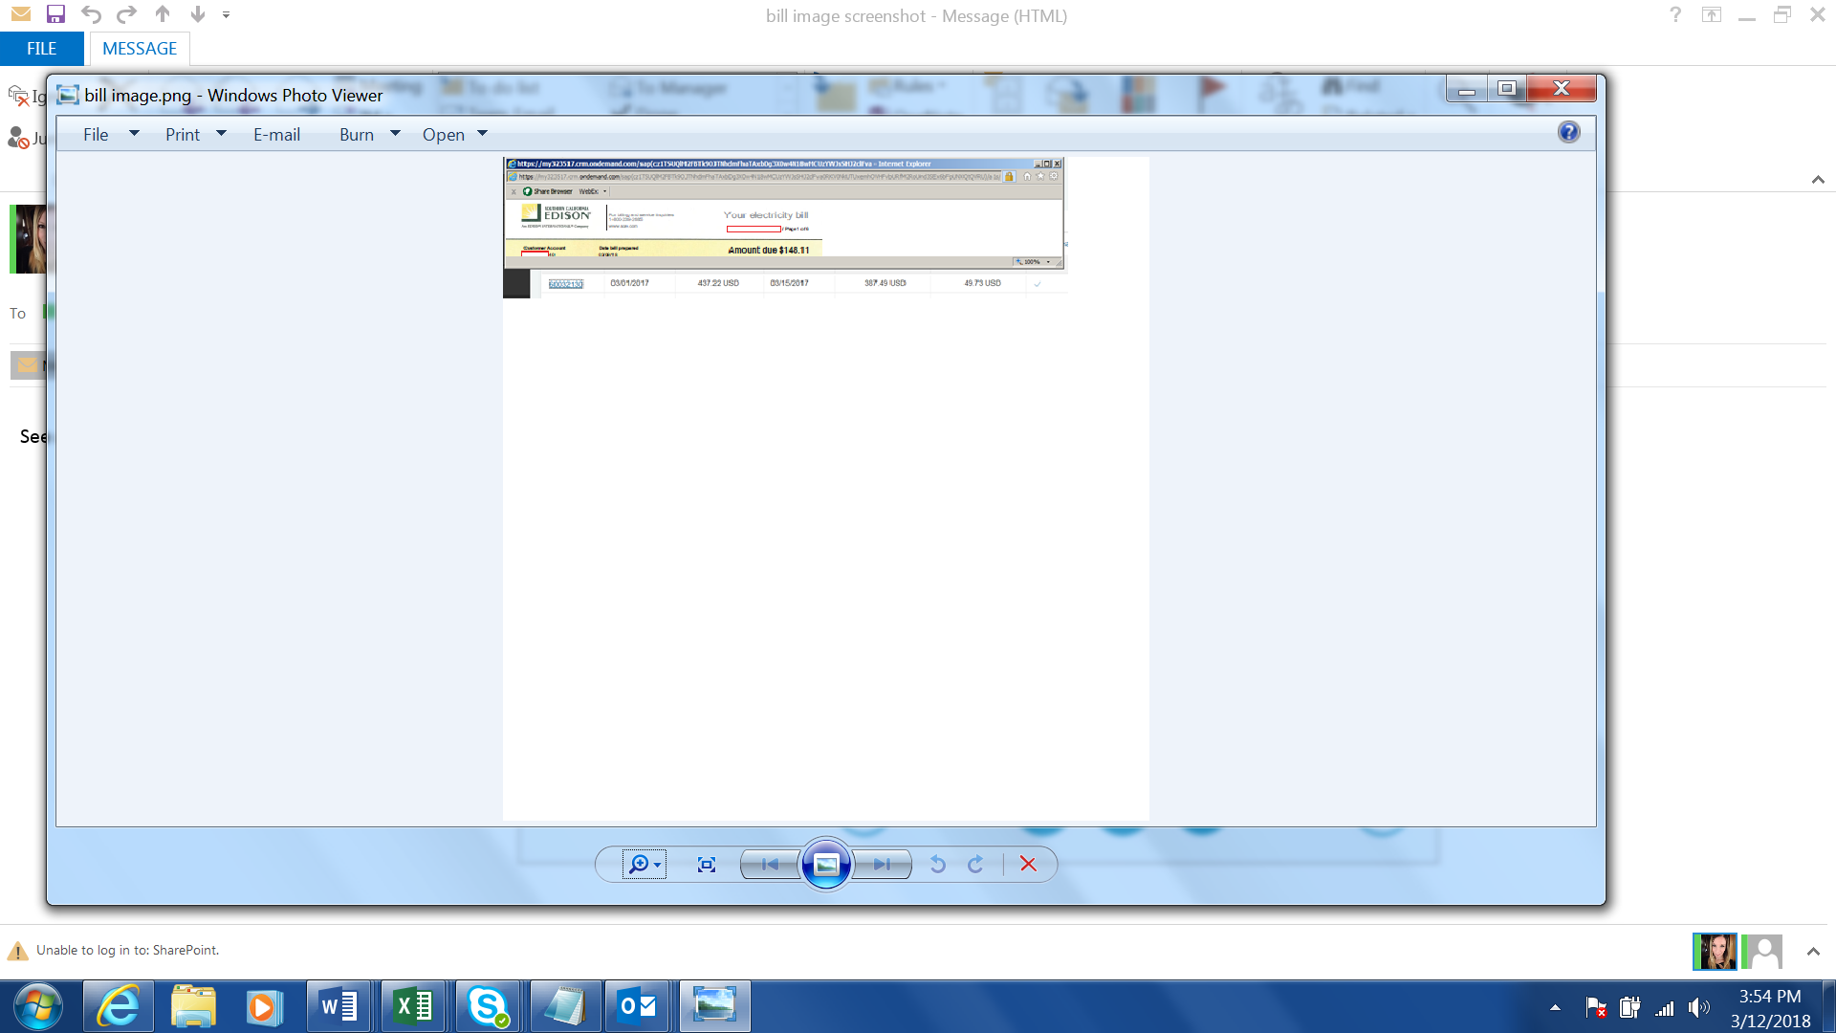
Figure 11: Hybris C4C Invoice number hyperlink

Legacy Invoices
SCE will be storing image of CSS invoices/bills starting 2018. These invoices are having metadata of legacy Contract Account number, Statement number, and Statement Date (refer to Action item 2366). These invoices will undergo metadata conversion using enhancement C-UB-BI-09 - Bill image PDF migrated to Open text during system go live. These invoices will have SAP Contract Account number after conversion. These invoices will be stored in Legacy Bill folder under ’Correspondence’ Business Workspace in the Hybris C4C Mashup view. Refer to BPD UB-BI-09 - Produce Invoice - Invoice Print for more information about legacy invoices.

Handling of delivered and undelivered correspondence
The delivery status of digital communications sent to customer via 3rd party notification system will be tracked by the 3rd party notification system and sent back to xECM for handling and storage. Interface between 3rd party notification system and S/4HANA will be done using I-CIM-CS-09 Interface between 3rd party notification and S/4. The handling process of delivered, undelivered or bounced back correspondence is documented in this section below.
Classification of hard bounce and soft bounce will be carried out with 3rd party notification system. Classifications to be defined upon selection of Third Party Vendor by SCE Business clients and IT. Classification of hard bounce and soft bounce will be carried out with 3rd party notification system and CCC/BCD user after the vendor is selected by SCE.
Handling of delivered and undelivered correspondence for TTY is similar to other communication channel. It depends on the capability of 3rd party notification system.
A BP Contact is always created when an outbound correspondence is sent to the customer (refer to BPD CIM-CS-11 Handle Outbound Request for more information). BP Contact will have the following information:
- Class – ‘Outbound Correspondence’
- Action – Letter Id
- Type – Either ‘Email’ or ‘SMS’ or ‘Phone’ or ‘Mail’ or ‘TTY’
- In/Outgoing – ‘Outgoing’
- Date/Time – Correspondence creation date & time
The outbound correspondence delivery status is updated to the BP Contact created for the outbound correspondence to reduce the number of BP Contract being created. The response from 3rd party notification will contain information such as BP number, correspondence Id, correspondence sent date and time for S/4HANA program to track the BP Contact to update.

Delivered and undelivered Emails
If the 3rd party notification system is able to successfully deliver the correspondence to the customer, 3rd party notification system will send the delivered email status notification in a file and store in the file server. The 3rd party notification system will only provide the final results of the communication process, meaning if the 3rd Party Notification system had to make multiple attempts the deliver the communication and successfully delivered it on the 3rd attempt (for example), a file with successful delivery status will be sent to SCE. Enhancement E-CIM-CS-09- Update contact detail as bad and update with a reason will process the file. E-CIM-CS-09 – Update Response to Original BP Contact will update the existing BP Contact created for the outbound correspondence with these additional information below:
- Additional Info – ‘Delivered Successfully’
- Long Text – Containing text ‘Delivered successfully on <delivered date & time> and customer contact information <customer email id>’

If an email is undelivered after 3 retries (e.g., email server busy, customer has blocked SCE or the email address is inactive), the SCE email server will send the undelivered email status in a file to a file server. S/4HANA batch job will pick up these files for processing using E-CIM-CS-09- Update contact detail as bad and update with a reason.
If the undelivered email received is related to hard bounce such as invalid email address (e.g., inactive) or customer has blocked their Inbox from receiving SCE emails, the specific email address will be deleted by the system in S/4HANA automatically on all BPs having the invalid email address using enhancement E-CIM-CS-09- Update contact detail as bad and update with a reason.
The existing BP Contact created for the outbound correspondence will be updated with undelivered information using E-CIM-CS-09 – Update Response to Original BP Contact when the system successfully deleted the email address from the system on each BP. This type of BP Contact will be visible for user in Hybris C4C. If user wants to check the list of customer contact that has been deleted by the system for a particular period, user can use a self-service report to extract this type of BP Contact. If the email address is deleted from a BP, the existing BP Contact for the outbound correspondence will be updated with these additional information:
- Additional Info – ‘Undelivered – Hard bounce’
- Long Text – Containing text ‘Undelivered due to <reason> on <Undelivered date and time> and <email id> is deleted by system’.
If the invalid email address is deleted from multiple BPs, a new BP Contact will be created for each of the BP that does not have a BP Contact created for outbound correspondence using E-CIM-CS-09 – Update Response to Original BP Contact. The BP Contact will have these information:
- BP Name & BP Number
- Class – ‘Invalid Customer Info’
- Action – ‘Hard bounce’
- Type – ‘Email’
- In/Outgoing – ‘Incoming’
- Date/Time – System date and time
- Long Text – Containing text ‘Invalid customer contact information <reason>. <email id> is deleted by system’.
If the system is unable to delete the email address (e.g., user has the BP open in the system for editing or other failure reason) a Ticket ‘Account Maintenance – Contact/Alert Preferences’ will be created automatically using E-CIM-CS-09- Update contact detail as bad and update with a reason when the system failed to delete the BP’s email. If the BP is an unassigned the Ticket will be sent to CCC OLS and if the BP is assigned it will be sent to the Account Manager. The Correspondence Name, customer email id and failure reason will be updated in the Ticket long text.
Offline Support or BCD Account Manager will attend to the Ticket and attempt to delete or update the BP master with the correct email id. Offline Support or BCD COE will create an Activity after the customer contact information is corrected in Hybris C4C BP master (Figure 12).
After updating the contact and alert preference information for the BP, they will forward the Ticket to the communication owner OR create another Ticket so the communication owner can further investigate why the automated process didn’t work correctly and work with IT if needed. For example, if the failure was related to an Outage Alert they will send the Ticket to the BCD outage team. We will further define who the communication owners will be for what types of communications during the Business Process Procedure phase.

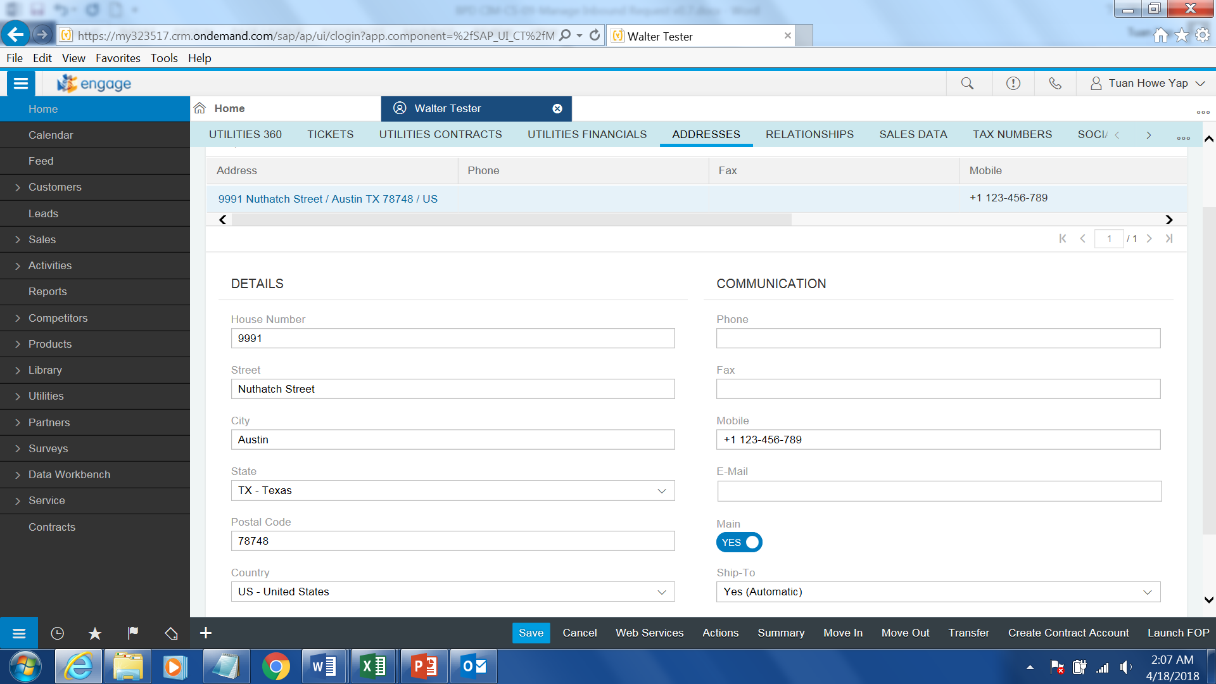
Figure 12: Update email in C4C

- If the undelivered correspondence reason was due to soft bounce such as email server is temporary down, system will not delete the BP’s email id. The existing BP Contact created for the outbound correspondence will be updated by system with undelivered information using E-CIM-CS-09 – Update Response to Original BP Contact. This type of BP Contact will be visible in the Hybris C4C view. User can execute a self-service report to extract this type of BP Contact if needed. The existing BP Contact be updated with the following information:
- Additional Info – ‘Undelivered – Soft bounce’
- Long Text – Containing text ‘Undelivered due to <reason> on <undelivered date and time> and email Id

Refer to BPD CIM-CS-01 - Business Master Data - Manage Business Partner for more information in updating customer contact.

Delivered and undeliverable SMS Messages
If the 3rd party notification system is able to successfully deliver the correspondence to the BP, 3rd party notification system will send the delivered SMS file in the file server. S/4HANA batch job will pick up these file for processing using E-CIM-CS-09- Update contact detail as bad and update with a reason. The existing BP Contact created for outbound correspondence will be updated with the additional information below using E-CIM-CS-09 – Update Response to Original BP Contact:
- Additional Info - <Delivered successfully>
- Long Text – Containing text ‘Delivered successfully on <delivered date & time> and customer contact information <Mobile number>’

If an SMS communication cannot be successfully delivered to the recipient after 3 retries, the 3rd party notification system will drop the undelivered SMS file in the file server. S/4HANA batch job will pick up these files for processing. If the delivery failure was because the phone is no longer active or the BP has blocked SCE voice/SMS messages, the specific Mobile number will be deleted in S/4HANA automatically on all BPs using enhancement E-CIM-CS-09- Update contact detail as bad and update with a reason.
If the mobile phone number is deleted from a BP, the existing BP Contact for the outbound correspondence will be updated with these additional information using E-CIM-CS-09 – Update Response to Original BP Contact:
- Additional Info – ‘Undelivered – Hard bounce’
- Long Text – Containing text ‘Undelivered due to <reason> on <undelivered date and time> and <mobile phone number> is deleted by system’.
If the mobile phone number is deleted from multiple BPs, a new BP Contact will be created for each of the BP that does not have a BP Contact created for outbound correspondence using E-CIM-CS-09 – Update Response to Original BP Contact. The BP Contact will have these information:
- BP Name & BP Number
- Class – ‘Invalid Customer Info’
- Action – ‘Hard bounce’
- Type – ‘SMS’
- In/Outgoing – ‘Incoming’
- Date/Time – System date and time
- Long Text – Containing text ‘Invalid customer contact information <reason>. <Mobile phone number> is deleted by system’.
A Ticket will be create automatically using E-CIM-CS-09- Update contact detail as bad and update with a reason when the system failed to delete the BP’s phone number. Ticket ‘Account Maintenance – Contact/Alert Preferences’ will be created for Offline Support for un-assigned customers and BCD Account Manager for assigned customers to update the customer preference manually. The Correspondence Name, customer Mobile phone number and failure reason will be updated in the Ticket long text.
If the undelivered reason was due to soft bounce, the existing BP Contact be updated with the following information using E-CIM-CS-09 – Update Response to Original BP Contact:
- Additional Info – ‘Undelivered – Soft bounce’
- Long Text – Containing text ‘Undelivered due to <reason> on <undelivered date and time> and <mobile number>

The user will use the self-service report to extract the BP Contact and delete/update the BP’s mobile number (Figure 13) in Hybris C4C.


Figure 13: Update Mobile number

Delivered and undeliverable TTY Messages
If the 3rd party notification system is able to successfully deliver the correspondence to the BP, 3rd party notification system will send the delivered TTY file in the file server. S/4HANA batch job will pick up these file for processing using E-CIM-CS-09- Update contact detail as bad and update with a reason. The existing BP Contact created for outbound correspondence will be updated with the additional information below using E-CIM-CS-09 – Update Response to Original BP Contact:
- Additional Info - <Delivered successfully>
- Long Text – Containing text ‘Delivered successfully’ on <delivered date & time> and customer contact information <Mobile or Phone number>’

If a TTY communication cannot be successfully delivered to the recipient after 3 retries, the 3rd party notification system will drop the undelivered TTY file in the file server. S/4HANA batch job will pick up these files for processing. If the delivery failure was because the phone is no longer active or the BP has blocked SCE calls, the specific Mobile number or Phone number will be deleted in S/4HANA automatically on all BPs using enhancement E-CIM-CS-09- Update contact detail as bad and update with a reason.
If the mobile or phone number is deleted from a BP, the existing BP Contact for the outbound correspondence will be updated with these additional information using E-CIM-CS-09 – Update Response to Original BP Contact:
- Additional Info – ‘Undelivered – Hard bounce’
- Long Text – Containing text ‘Undelivered due to <reason> on <undelivered date and time> and <mobile or phone number> is deleted by system’.
If the mobile or phone number is deleted from multiple BPs, a new BP Contact will be created for each of the BP that does not have a BP Contact created for outbound correspondence using E-CIM-CS-09 – Update Response to Original BP Contact. The BP Contact will have these information:
- BP Name & BP Number
- Class – ‘Invalid Customer Info’
- Action – ‘Hard bounce’
- Type – ‘TTY’
- In/Outgoing – ‘Incoming’
- Date/Time – System date and time
- Long Text – Containing text ‘Invalid customer contact information <reason>. <Mobile or phone number> is deleted by system’.
A Ticket will be create automatically using E-CIM-CS-09- Update contact detail as bad and update with a reason when the system failed to delete the BP’s mobile or phone number. Ticket ‘Account Maintenance – Contact/Alert Preferences’ will be created for Offline Support for un-assigned customers and BCD Account Manager for assigned customers to update the customer preference manually. The Correspondence Name, customer Mobile phone number and failure reason will be updated in the Ticket long text.
If the undelivered reason was due to soft bounce, the existing BP Contact be updated with the following information using E-CIM-CS-09 – Update Response to Original BP Contact:
- Additional Info – ‘Undelivered – Soft bounce’
- Long Text – Containing text ‘Undelivered due to <reason> on <undelivered date and time> and <mobile or phone number>

The user will use the self-service report to extract the BP Contact and delete/update the BP’s mobile number (Figure 13) in Hybris C4C.

Delivered and undeliverable Voice Call
If the 3rd party notification system is able to successfully deliver the correspondence to the BP, 3rd party notification system will send the delivered voice call file in the file server. S/4HANA batch job will pick up these file for processing using E-CIM-CS-09- Update contact detail as bad and update with a reason. The existing BP Contact created for outbound correspondence will be updated with the additional information below using E-CIM-CS-09 – Update Response to Original BP Contact:
- Additional Info - <Delivered successfully>
- Long Text – Containing text ‘Delivered successfully on <delivered date & time> and customer contact information <Mobile number>’
If a voice communication cannot be successfully delivered to the recipient after 3 retries, the 3rd party notification system will drop the undelivered voice call file in the file server. S/4HANA batch job will pick up these files for processing. If the delivery failure was because the phone is no longer active or the BP has blocked SCE calls, the specific phone or mobile number will be deleted in S/4HANA automatically on all BPs using enhancement E-CIM-CS-09- Update contact detail as bad.
If the phone/mobile phone number is deleted from a BP, the existing BP Contact for the outbound correspondence will be updated with these additional information using E-CIM-CS-09 – Update Response to Original BP Contact:
- Additional Info – ‘Undelivered – Hard bounce’
- Long Text – Containing text ‘Undelivered due to <reason> on <undelivered date and time> and <mobile phone number> is deleted by system’.
If the mobile phone number is deleted from multiple BPs, a new BP Contact will be created for each of the BP that does not have a BP Contact created for outbound correspondence. The BP Contact will have these information using E-CIM-CS-09 – Update Response to Original BP Contact:
- BP Name & BP Number
- Class – ‘Invalid Customer Info’
- Action – ‘Hard bounce’
- Type – ‘Phone’
- In/Outgoing – ‘Incoming’
- Date/Time – System date and time
- Long Text – Containing text ‘Invalid customer contact information <reason>. <Phone/Mobile phone number> is deleted by system’.
A Ticket will be create automatically using E-CIM-CS-09- Update contact detail as bad and update with a reason when the system failed to delete the BP’s email. Ticket ‘Account Maintenance – Contact/Alert Preferences’ will be automatically created for Offline Support for un-assigned customers and BCD Account Manager for assigned customers to update the customer preference manually. The Correspondence Name, customer Phone/Mobile phone number and failure reason will be updated in the Ticket long text.
If the undelivered reason was due to soft bounce, the existing BP Contact be updated with the following information using E-CIM-CS-09 – Update Response to Original BP Contact:
- Additional Info – ‘Undelivered – Soft bounce’
- Long Text – Containing text ‘Undelivered due to <reason> on <undelivered date and time> and <phone/mobile number>
The user will use the self-service report to extract the BP Contact and update/delete the BP’s phone or mobile number (Figure 13) in Hybris C4C.

U.S. mail
If the mailing address for a BP is incorrect, the U.S. mail will be returned to SCE. User will reach out to the customer to obtain the correct mailing address and update mailing address in BP master via Hybris C4C (Figure 14). If user is not able to obtain the correct address from the customer and if the communication type supports it, user can go to Customer Preference Center to disabled U.S. mail and change it email or SMS as the customer’s preferred communication channel. Refer to BPD CIM-CS-01 - Business Master Data - Manage Business Partner for more information. An Activity will be created by the user manually documenting the reason, date and time of return mail.

Figure 14: Update mailing address

Handling of Opt Out Request
Email Opt-Out
A customer can select to opt-out of a SCE outbound email correspondence by selecting the unsubscribe links at the footer of the email. If BP clicks on the “Unsubscribe” link, the web service (using I-CIM-CS-09 Web Service for Opt Out Correspondence Request via email) will update the customer preference in S/4HANA and opt out customer from this particular correspondence. If BP clicks on the ‘Unsubscribe All” link, all the correspondences that are having ‘email’ as preferred communication channel will be opt out for the BP using I-CIM-CS-09 Web Service for Opt Out Correspondence Request via email.
If the system failed to update customer preference, a Ticket ‘Account Maintenance - Alert Opt-Out Process Failed’ will be created for Offline Support for unassigned customer and BCD Account Manager for assigned customer to update the customer preference manually. The Correspondence Name, customer email id and opt out a correspondence or opt out all correspondence will be updated in the Ticket long text.
The system will locate the BP Contact created for the outbound correspondence based on BP number, correspondence id and date & time sent using E-CIM-CS-09 – Update Response to Original BP Contact. The BP Contact will be updated with the information below:
- Class - No update required. Value remains the same. E.g. Outbound Correspondence
- Action – No update required. Value remains the same. E.g. Letter Id
- Additional Info – ‘Opt Out’
- Type – No update required. Value remains the same such as ‘Email’
- In/Outgoing – No update required. Value remains the same. E.g. ‘Outgoing’
- Date/Time – No update required
- Long Text – Containing text ‘Customer replied <Opt-Out> or <Opt-Out All> and customer contact information <customer email id>’
It is not expected for system to automatically opt out the BP from the preference center when customer reply to the outbound correspondence email as clicking on the unsubscribe links to opt out correspondence is the only option to opt out via email.

SMS Opt-Out
Customer can reply to a SCE SMS correspondence and request to opt out of any future correspondence by texting STOP or STOP ALL. The 3rd party notification system passes the SMS reply in a file and places it in a file server. The S/4HANA batch program will then process the Opt Out SMS file according the type of opt-out reply for all instances where that phone is enrolled in SMS communication for a BP by updating the Customer Preference using enhancement E-CIM-CS-09 - Opt out correspondence indicator for the customer Refer to BPD CIM-CS-01 - Business Master Data - Manage Business Partner for more information.
If the customer replies the SMS with key words ‘STOP’, the system will opt out the mobile phone from SMS as the preferred channel for that correspondence/communication type. If the customer replies with ‘STOP ALL’, customer will be opted out from all correspondences having SMS as the preferred channel. These are done using E-CIM-CS-09 - Opt out correspondence indicator for the customer. This policy must be followed to meet TCPA compliance laws. Once the customer is successfully opted out from the correspondence(s), system will send a SMS to customer ‘Thank you, you have been unenrolled,’ for your reply’ using E-CIM-CS-09- Send automatic outbound acknowledgement.
If the system failed to update customer preference, a Ticket Account Maintenance - Alert Opt-Out Process Failed’ will be created using E-CIM-CS-09 - Opt out correspondence indicator for the customer for Offline Support for unassigned customer and BCD COE for assigned customer to update the customer preference manually. The Correspondence Name, customer Mobile phone number and opt out a correspondence or opt out all correspondence will be updated in the Ticket long text.
The system will locate the BP Contact created for the outbound correspondence based on BP number/name, correspondence id and date & time sent using E-CIM-CS-09 – Update Response to Original BP Contact. The BP Contact will be updated with the additional information below:
- Additional Info – ‘Opt Out’
- Long Text – Containing text ‘Customer replied <Opt-Out> or <Opt-Out All> and customer contact information <Mobile number>’

Handling of TTY SMS correspondence reply from customer will be the same as a SMS mentioned above. Refer to CIM-CS-01 - Business Master Data - Manage Business Partner for information about the indicator for TTY.

Voice Call Opt-Outs
The customer can opt-out of voice communications from SCE when the option is provided as part of the outbound communication. An example is the user can press 1, to un-enroll from future voice communications for Outage Alerts.
The 3rd party notification system passes the voice call reply in a file and place it in a file server, the S/4HANA batch program will then process the Opt Out voice call file by updating the Customer Preference using enhancement E-CIM-CS-09 - Opt out correspondence indicator for the customer and logging the reason. Refer to BPD CIM-CS-01 - Business Master Data - Manage Business Partner for more information.
If the system failed to update customer preference, a Ticket ‘Account Maintenance - Alert Opt-Out Process Failed’ will be created using E-CIM-CS-09 - Opt out correspondence indicator for the customer for Offline Support for unassigned customer and BCD Account Manager for assigned customer to update the customer preference manually. The Correspondence Name, customer Phone or Mobile phone number and opt out a correspondence or opt out all correspondence will be updated in the Ticket long text.
The system will locate the BP Contact created for the outbound correspondence based on BP number/name, correspondence id and date & time sent using E-CIM-CS-09 – Update Response to Original BP Contact. The BP Contact will be updated with the additional information below:
- Additional Info – ‘Opt Out’
- Long Text – Containing text ‘Customer replied <Opt-Out> and contact information <customer phone/mobile number>’

U.S. mail
Customer can request to opt out of any correspondence via US mail. User will navigate to Customer Preference Center to opt out customer from the correspondence. Refer to BPD CIM-CS-01 - Business Master Data - Manage Business Partner for more information. An Activity will be created by user in Hybris C4C manually.
When there is an opt-out request via US mail is received, user will update the BP’s preference center manually. Refer to CIM-CS-01 - Business Master Data - Manage Business Partner for more information about the indicator for TTY.

Handling of Outage Restoration response
Various types of Outage Restoration Alerts are sent to BP or a non BP when an outage is identified, refer to CIM-CS-11 Handle Outbound Request for more information. BP or non-BP is able to reply to alert via the communication channel that the alert customer received. The reply can be outage is restored or outage is still on going. Handling of outage restoration response from BP in this section and the types of Outage Restoration alert are as followings:
- Emergency Maintenance Outage Power Restoration Alert
- Repair Outage Restoration Alert
- Maintenance Outage Restoration Alert

The Service Order created for the Outage Alert can be for a BP or a non BP. BP number can be found in the Service Order if it is created for a BP. Otherwise, the non-BP address information is maintained in the Service Order. System will use these information to retrieve Service Order to update the Service Order status.

Email response
A customer can reply to the Outage Alert email by selecting the Outage Reply links at the footer of the email. If BP clicks on the “POWER ON” link, the web service (using I-CIM-CS-09 Web Service for Outage Alert Response via email) will update the existing Outage Order’s status to ‘Completed’ if there is an active Trouble Service Order for the account. If the system failed to update the Service Order, a BPEM case ‘Outage Restoration Alert’ will be created for OLS Team to work on.
If BP clicks on the ‘POWER OFF” link the web service will create a new Service Order in S/4HANA and field service personnel will work on the Outage.
If the system is unable to create a new SO Trouble order, the system will create a BPEM ‘Outage – Trouble Order Needed’ to OLS to manually create the SO Trouble order.
The system will locate the BP Contact created for Outage Alert based on BP number, correspondence id and date & time sent using E-CIM-CS-09 – Update Response to Original BP Contact. The BP Contact will be updated with the reply information below:
- Additional Info – ‘POWER ON’ or ‘POWER OFF’
- Long Text – Containing text ‘Customer replied <POWER ON/POWER OFF>’. If a new Service Order is created, additional long text ‘Service Order is created’.
It is not expected for system to process the Outage Alert reply when customer reply to the outbound correspondence email as clicking on the ‘POWER ON’ or ‘POWER OFF’ link is the only option for customer to report outage status via email.

SMS response
Customer can reply to an Outage Alert SMS correspondence reporting the status of the outage. The 3rd party notification system passes the SMS reply in a file and places it in a file server. The S/4HANA batch program will then process the SMS file according the type of reply from customer using E-CIM-CS-09 – Manage Outage Alert Response.
If the customer reply the SMS with key words ‘POWER OUT’, the program (E-CIM-CS-09 – Manage Outage Alert Response) will create a new Trouble Order in S/4HANA and field service personnel will work on the Outage.
If the customer replies to the SMS with key words ‘POWER ON’, the existing Service Order status will be updated with ‘Completed’ if one is active for the account. If the system failed to create the Service Order, a BPEM case ‘Outage – Trouble Order Needed’ will be created for Grid Ops Dispatch Team to work on.
If the SMS response is anything other than ‘POWER OUT’ or ‘POWER ON’, the system will not process these SMS response. BP Contact will not be created and a copy of the response will not be uploaded to xECM.
The system will locate the BP Contact created for Outage Alert based on BP number, correspondence id and date & time sent using E-CIM-CS-09 – Update Response to Original BP Contact. The BP Contact will be updated with the reply information below:
- Additional Info – ‘POWER ON’ or ‘POWER OFF’
- Long Text – Containing text ‘Customer replied <POWER ON/POWER OFF>’. If a new Service Order is created, additional long text ‘Service Order is created’.

Voice call response
Outage Restoration Alert voice calls will enable the recipient to take immediate action during the outbound call by allowing a BP or a non BP an option at the end of the call to advise if their power was restored by pressing 1 or that their power is still out by pressing 2. The 3rd party notification system will send response from BP to SCE in a file and store in the file server in near real-time. S/4HANA will process these file using E-CIM-CS-09 – Manage Outage Alert Response.
If the customer presses 1, the existing Service Order status will be updated with ‘Completed’ If the system failed to update the Service Order, a BPEM case ‘Outage Restoration Alert’ will be created for OLS Team to work on.
If the customer presses 2, the program (E-CIM-CS-09 – Manage Outage Alert Response) will create a new Service Order in S/4HANA and field service personnel will work on the Outage.
If the system failed to create the Service Order, a BPEM case ‘Outage – Trouble Order Needed’ will be created for OLS Team to work on.
The system will locate the BP Contact created for Outage Alert based on BP number/name, correspondence id and date & time sent using E-CIM-CS-09 – Update Response to Original BP Contact. The BP Contact will be updated with the additional information below:
- Additional Info – ‘POWER ON’ or ‘POWER OFF’
- Long Text – Containing text ‘Customer replied <POWER ON/POWER OFF>’. If a new Service Order is created, additional long text ‘Service Order is created’.

Process / Performance Improvement
- MS Outlook will be integrated with Open Text, a copy of the email from the customer can be uploaded to Open Text without forwarding the email to a dedicated email inbox in Kofax
- SMS and voice call from customer will be uploaded to a file server in a file format by 3rd party notification system
- Email server performance might get impacted as users will email scanned document to their email inbox and uses MS Outlook to upload document to xECM.
- Customers will be able to easily opt-out of any digital communication and the system will automatically process it for the customers.
- Customer will be able to advise the power is out via email, voice, TTY or SMS while today, we only enable it for a limited number of outbound voice outage calls when IVR is used.
- All C4C and S/4HANA users will be able to view the delivery status of digital communications, opt-outs and other customer responses.

Prerequisites and Inputs
- Metadata entered for correspondence should be validated in SAP by user manually prior to uploading the correspondence into Open Text xECM
- Kofax is integrated with Open Text xECM to upload and store correspondence image
- Open Text xECM is integrated with S/4HANA for viewing of correspondence image
- MS Outlook is integrated with Open Text xECM to upload and store correspondence image
- Integration with a 3rd party communication vendor with a near real-time interface to receive the delivery result of communications and customer responses.

General Assumptions
- Open Text xECM allows user to store correspondence image in predefined folders. Folders are configurable in Open Text
- Correspondence image file in xECM is date and timestamped
- Open Text xECM is integrated with SCE MS Outlook and MS Outlook will have an add-on that allows the user to upload a copy of the email to xECM directly
- 3rd party notification system will provide the SMS & voice call response from customer to Open Text along with the BP or Contract Account number and the SMS response content
- 3rd party notification system will provide the TTY, SMS & voice call response from customer in a file format and push the file to SCE file server. The file should contain SAP object such as BP, Contract Account or Contract information
- Open Text is able to restrict authorized users to view confidential correspondence
- SharePoint will not be integrated with Open Text
- SCE will develop and define the business process of handling return US mail from US postal service. The development of this process will take time and will continue after the approval of this BPD. CP&S is heading this initiative.
- HEER application fulfillment process will be carried out in Market Place application
- Users that do not have access to KoFax will use the MFM to scan document and email document to themselves and upload the document to xECM via MS Outlook
- Hybris Marketing inbound communication responses will be defined in the Campaign Segmentation BPD CIM-CS-15 - Manage Customer Segmentation & Campaign Management
- OLS team will utilize S/4HANA to attend to the BPEM cases that are assigned to them
- Real Time Text (RTT) is a new technology that will eventually replace TTY. The system will be able to handle Real Time Text (RTT). This is subject to 3rd party notification system capability
- When the system is not able to automatically remove the communication method deemed as “bad”, the system will create a Ticket case for a user to manually remove the communication method. It is expected that the user will work the Ticket case in a timely manner. Until the communication method is removed, SCE will continue to send notifications that will fail.
- Kofax is unable to add Contract or Contract Account as metadata when uploading to Open Text unless an enhancement to Kofax is funded and implemented.

Business Process Hierarchy
Level 1 FO or BO | Level 2 Business Process(BPD) | Level 3(Sub Processes) | Level 4(SAP Transaction Codes
Front Office | Manage Inbound Request | View correspondence image | Open Text xECM in C4C Mashup
Front Office | Manage Inbound Request | Create Activity | Hybris C4C Activity
Front Office & Back Office | Manage Inbound Request | Create BP Contact | BTC0
Back Office | Manage Inbound Request | View correspondence image | S/4HANA xECM
Front Office | Manage Inbound Request | Update & delete BP master (customer contact information) | C4C Business Partner
Back Office | Manage Inbound Request | Update & delete BP master (customer contact information) | S/4HANA tocde BP
Grid Ops Dispatch Team | Manage Inbound Request | Update and view BPEM case | S/4HANA EMMAC2
BCD Account Manager | Manage Inbound Request | Create and update Ticket | C4C Ticket

Process Flows
Below is the Process flow diagram for Inbound Correspondence.

2.9.1 Upload Correspondence to Open Text

Process Flow Steps
Step | Description of Step | Hybris C4C / T-Code | Role(s)
10 | Start | N/A | N/A
20 | SCE receives correspondence  SCE received correspondence from customer | N/A | N/A
30 | If channel is email/e-fax/SMS?  If correspondence from customer is sent via email/e-fax or SMS, go to step 40. Otherwise go to step 60. | N/A | N/A
40 | Login to MS Outlook  User logins to MS Outlook | MS Outlook | Inbound Correspondence
50 | Upload Correspondence to xECM  User upload the email/e-fax/SMS to xECM. | MS Outlook | Inbound Correspondence
60 | If channel is US mail?  If correspondence from customer is sent via US mail, go to step 70. Otherwise go to step 130. | N/A | N/A
70 | Access to Kofax?  If user has access to Kofax, go to step 90. Otherwise, go to step 80. | N/A | N/A
80 | Scan using MFM  User scan correspondence using multi-function machine and email softcopy to themselves. Go to step 40. | MFM | Inbound Correspondence
90 | Login to Kofax  User login to Kofax. | Kofax | Inbound Correspondence
100 | Scan Correspondence  User scan correspondence using Kofax. | Kofax | Inbound Correspondence
110 | Upload Correspondence to xECM  User upload scanned correspondence to xECM. | Kofax | Inbound Correspondence
120 | Requires BPEM case?  If the inbound correspondence requires BPEM case to be created, go to step 150. Otherwise, go to step 130. | N/A | N/A
130 | If channel is SMS?  If correspondence from customer is sent via SMS, go to step 140. Otherwise go to step 170. | N/A | N/A
140 | Correspondence is uploaded to xECM  Correspondence is uploaded to xECM. | Open Text | N/A
150 | Create BP Contact automatically  xECM triggers S/4HANA program to create BP Contact automatically | BCT0 | Inbound Correspondence
160 | Create BPEM case automatically  Kofax triggers S/4HANA program to create BPEM case automatically. | S/4HANA EMMAC1 | Inbound Correspondence
170 | End

2.9.2 Handle opt out and undelivered correspondence

Process Flow Steps
Step | Description of Step | Hybris C4C / T-Code | Role(s)
10 | Start | N/A | N/A
20 | SCE receives correspondence  SCE received correspondence from customer | N/A | N/A
30 | Undelivered/bounced back?  The outbound correspondence sent to customer is undelivered/bounced back to SCE? | N/A | N/A
40 | Customer request opt-out?  If customer is requesting to opt-out of receiving correspondence, go to step 50. Otherwise, go to step 180. | N/A | N/A
50 | If channel is email?  If response from customer is sent via email, go to step 60. Otherwise, go to step 70. | N/A | Inbound Correspondence
60 | Check MS Outlook for opt-out request  User login to MS Outlook to look for any opt-out request from customer. Go to step 80. | MS Outlook | Inbound Correspondence
70 | Update Customer Preference  Customer Preference for the BP is updated with Opt Out. Go to step 180. | S/4HANA | N/A
80 | Manage customer preference  User update customer preference via CIM-CS-01. Go to step 170. | S/4HANA | Inbound Correspondence
90 | If channel is email/e-fax/SMS/voice call?  If customer sent reply via email/e-fax/SMS/voice call, go to step 100. Otherwise, go to step 180. | N/A | N/A
100 | Hard bounce?  If the undelivered reason is due to hard bounce, go to step 110. Otherwise, go to step 150. | N/A | N/A
110 | Failed to delete/soft bounce?  If system failed to delete customer contact information or undelivered reason is due to soft bounce, go to step 130. Otherwise, go to step 170. | N/A | N/A
120 | Delete customer contact info  Customer contact (email or Mobile or phone) is deleted | S/4HANA | Inbound Correspondence
130 | Create BP Contact  BP Contact is created based on the undelivered reason. | S/4HANA | Inbound Correspondence
140 | Execute self-service report  Execute self-service report to update customer contact on those records that failed to be deleted by system. | S/4HANA BI | Inbound Correspondence
150 | Update customer contact information  User update BP master with new customer contact information via CIM-CS-01 process. | S/4HANA tcode BP | Inbound Correspondence
160 | Create Activity  Create an Activity | Hybris C4C | Inbound Correspondence
170 | End

2.9.3 Viewing correspondence image

Process Flow Steps
Step | Description of Step | Hybris C4C / T-Code | Role(s)
10 | Start | N/A | N/A
20 | Back Office?  If Back Office user, go to step 50. Otherwise, go to step 40. | N/A | N/A
40 | Navigate to Mashup  Navigate to Mashup to view the document image. | Hybris C4C Mashup xECM | Inbound Correspondence
50 | Folders and document files are shown  Folders and files for the document image are shown on the screen. | Hybris C4C Mashup xECM | Inbound Correspondence
60 | Double click file to view  Double click file to view document image. Go to step 110. | Open Text | Inbound Correspondence
70 | Execute any tcode  In S/4HANA main screen, enter and execute any tcode. | S/4HANA | Inbound Correspondence
80 | Select from menu  Select xECM Business Content option from menu. | S/4HANA xECM | Inbound Correspondence
90 | Folders and document files are shown  Folders and files for the document image are shown on the screen. | Open Text | Inbound Correspondence
100 | Double click file to view  Double click file to view document image. | Open Text | Inbound Correspondence
110 | Handle Outbound Request  User to print or send document to customer if required. | Open Text | Inbound Correspondence
120 | End

3rd Party and SCE Legacy System Integrations
3rd Party or SCE Legacy System Integration | Description of Integration and Required Change to 3rd Party or SCE Legacy System | Estimated Complexity of 3rd Party or SCE Legacy system change
Open Text Extended Enterprise Content Management (xECM) | Document repository system from Open Text | Medium
Kofax | Correspondence scanning tool. Interface to xECM is required  Propose Kofax to allow user to tag BP #, CA # and Contract # as metadata to the correspondence). | Medium
MS Outlook | Email from customer is sent to SCE email.  xECM add on to MS Outlook and user is able to upload document to xECM using BP, CA and Contract number as metadata. | Medium
3rd party notification system | 3rd party notification system that sends SMS, email, Voice call to customer and receives response from customer.  Interface between Open Text (xECM. Empower Editor) & S/4HANA and 3rd party notification system is needed  3rd party notification system would be able to send email, SMS and voice call to customer. It would be able to receive email, SMS and voice call response from customer. If delivered or undelivered, 3rd party notification system is able to provide the status and reason. | Medium

Data Elements
Field | Type | Comments
Business Partner | Optional | Business Partner number that can be used as one of the metadata for the correspondence image
Contract Account | Optional | Contract Account number can be used as one of the metadata for the correspondence image
Contract | Optional | Contract number can be used as one of the metadata for correspondence image
Legacy Business Partner | Optional | Applicable for invoices that store in Open Text prior SAP go live
Legacy Contract | Optional | Applicable for invoices that store in Open Text prior SAP go live

Source Systems and Data Volumes
N/A

Cloud for Customer (C4C) Integration

Processes
- Storing document image
- Display correspondence images
- Delete correspondence image.

C4C Views
N/A

Activity / BP Contact
- BP Contact : Inbound correspondence is uploaded to xECM
- BP Contact : Correspondence is undelivered
- BP Contact : Correspondence response

Exception Management Requirements
This section outlines a high level description of each BPEM Case or other user workflow items (such as “Tickets” used by Front Office) used to route work requests between business areas. The companion document for this section which outlines the detail of each case is documented in APSE on the Exception Case Template General Document #8.

User Exception Scenario / Description | User Group | Initiated by | Work Distribution
BPEM cases for SDP Application’, ‘MBL Application’, ‘Income Qualified Program’ are document in BPD PP-CS-02 - Program Enrollment and Delivery, De-Enrollment & Decommission Programs

Process Risks and Mitigation

Risk Statement | Mitigation
If a BP record is locked by a user when the system tries to remove a communication method due to hard error, the system will not be able to automatically remove the communication method | The system will create a Ticket for a user to manually make the update as needed.

Key Performance Indicators
The following have been identified as KPI’s at Southern California Edison, along with the means of measuring each KPI and the current measurement statistic for each KPI:
Measured KPI | Description | Measurement Method | Current Statistic
Correspondence Processing | Percentage of correspondence items (mail, e-fax, etc.) responded to within specified time frames. This is not a Control driven KPI. | Report
(Refer to the general document in APSE -General Document #31)

Key Metric Definition
The following have been identified as key metrics at Southern California Edison that require business rule for calculation:
Key Metric | Description | Business Rule | Reference
N/A

Controls, Regulatory Rules, and Security

Requirement  ID (from RTM) | “As-Is” Control Requirement | “To Be” Risk Statement | “To-Be” Control Activity” | Control Automation (manual, IT dependent- manual, automated | Relevant technical identifier or RICEFW reference
N/A

Security Considerations
Role | Transaction Code (T-Code) | T-Code Description | Authorization Attributes | SOD Conflicts (Yes/No)  If SOD Conflicts Yes. Identify the 2 conflicting t-codes
Inbound Correspondence | OpenText xECM | Open Text repository system | Able to view correspondence image | No
Inbound Correspondence | OpenText xECM | Open Text repository system | Able to delete correspondence image | No
Inbound Correspondence | S/4HANA xECM | Open Text repository system | Able to view correspondence image in S/4HANA | No
Inbound Correspondence | S/4HANA BCT0 | BP Contact | Create | No
Inbound Correspondence | S/4HANA EMMAC1 | BPEM case | Create | No
Inbound Correspondence | Hybris C4C Business Partner | Business Partner master | Update/Delete customer contact information | No
Inbound Correspondence | S/4HANA BP | Business Partner master | Update/Delete customer contact information | No
Inbound Correspondence | Hybris C4C | Ticket | Able to Create/Update/View Ticket | No

Custom Program/Transaction Codes

Custom Program | Authorization Grp | Custom T-code | Authorization Object used in the authorization check statement
N/A

Custom Table/Transaction Codes
Custom Table | Authorization Grp Assigned | Custom T-code for the Table | Table Access (display/update)
N/A

Data Criticality and Cybersecurity Baseline Risks

Specify Access Classification /Special Handling or Regulatory Requirement | <Select all that apply>  ☒ PII - Personal Identifiable Information / Privacy Law  ☐ CEII - Critical Energy Infrastructure Information  ☐ FERC SOC (Standards of Conduct)  ☐ NERC CIP Confidential  ☐ Sarbanes-Oxley (SOX) financial reporting data  ☐ SCE utility data accessible by affiliate companies (CPUC)  ☐ PCI - Payment Card Industry Compliance  ☒ Customer Information Service Request (CISR, CISR-DRP)  ☐ Other _<Please Specify>_  ☒ Internal  ☒ Public
Please identify which business Group/Role will require access to the data and/or solution: | <Select all that apply>  ☒ SCE Customer, Res./Comm. Customer;  ☒ SCE OU, Business Function Organization Name: CCC, BCD, CP&S; RSO-CAPS; RSO-CBO  ☐ Vendor  ☐ External business partner(s) & SaaS providers  ☐ External on-shore contractors  ☐ External off-shore contractors  ☐ SCE Affiliate Company Employees  ☒ SCE Employees, specify if they have Marketing Function responsibilities (e.g., ES&M)  ☒ SCE contract workers  ☐ Regulatory Agencies  ☐ Others _<Please Specify>_
How many of the SCE Customer, Employee, Venodors will use or affected by the Business Process? | 100; 100 – 1,000; …..  100-1,000
How much Infomration/data would be processed, received or tramitted by the Business Process? | 100; 100 – 1,000; …..
Number of business transactions in average? | 1,000+
Additional Security Consideration: | Any Cybersecurity impact in addition to SAP system security:  - Internet Facing Web Application? Yes/No, Detials: C4C is a cloud based application.  - Internet Facing Application Programming Interface? Yes.  - 3rd party Fedrated Authentication & Authorization, Single Sign On? Yes.

Technical Consideration

RICEF-W Assessment
All of the Forms, Reports, Interfaces, Conversion items, Enhancements and Workflows (RICEF-W) that have been identified for this BPD are detailed in the tables below and will represent the totality of all RICEF-W items documented at the time of sign-off of this BPD. Any RICEF-W items that are identified after this BPD receives final sign-off will only be managed within Southern California Edison’s APSE environment and not within this document.

Reports
Description (include the Business Purpose) | Complexity | Reference ID
Ability to generate report with emails that bounce back, include Account Manager for Assigned Accounts with bounce back info, Customer Name, Contract Account, Contract, Contact Name email associated with.  Ability to generate report with phone numbers that bounce back, include Account Manager for Assigned Accounts with bounce back info, Customer Name, Contract Account, Contract, Contact Name phone number associated with  Ability to generate report with U.S. Mail returned, include Account Manager for Assigned Accounts with mailing address info, Customer Name, Contract Account, Contract, Contact Name AM associated with. | Medium | R-CS-09 -Report on accounts having email bounce back
Ability to report on attachments (inbound/outbound) at any SAP Object level showing BP number/name, attachment name, added by, added date and time (This will be useful to track customer profile word documents attached by Account Managers to Business Partner) | Medium | R-CS-09- Report for list of inbound and outbound communication to a BP
Ability to generate report with campaign information for successful- unsuccessful communication sent. | Medium | R-CS-09-Report on campaign

Interfaces
Description (include the Business Purpose) | Complexity | Reference ID
Interface between Kofax and Open Text xECM | Medium | I-CIM-CS-09 Interface between Kofax and OpenText xECM  ** This is a new TIER 1 RICEFW
Interface between MS Outlook and Open Text xECM | Medium | I-CIM-CS-09 Interface between MS Outlook and OpenText xECM  ** This is a new TIER 1 RICEFW
Interface between 3rd party notification system and S/4 | Medium | I-CIM-CS-09 Interface between 3rd party notification and S/4  ** This is a new TIER 1 RICEFW
Ability for system to opt out a customer from receiving a or all future email | Medium | I-CIM-CS-09 Web Service for Opt Out Correspondence Request via email  ** This is a new Tier 1 RICEFW
The system shall enable a recipient of a email Maintenance Outage Restoration Alert to indicate their power is still out via the alert (e.g., reply NO POWER or land on webpage to indicate no power) which will automatically create a TO for the premise. | Medium | I-CIM-CS-09 Web Service for Outage Alert Response via email  ** This is a new Tier 1 RICEFW

Conversion
Description (include the Business Purpose) | Complexity | Reference ID

Enhancements
Description (include the Business Purpose) | Complexity | Reference ID
Create a BP Contact whenever a correspondence is uploaded to xECM | Medium | E-CIM-CS-11 - Auto IR creation for Inbound & Outbound Correspondence/Communication  ** This will be changed to a Tier 1 RICEFW
Ability for system to send acknowledgement automatically for certain transactions/activities to customer that message/reply from customer is received by SCE. This shall be configurable. | Medium | E-CIM-CS-09- Send automatic outbound acknowledgement
Ability for system or mass update to mark email address as inactive along with the reason after received a hard bounce back for the email. A log file will be generated  Ability for system or mass update to mark email address as inactive along with a reason after received x times of soft bounce (configurable number of time). A log file will be generated  Ability for system or mass update to indicate phone number as inactive with a reason due to undelivered text/phone because phone is inactive. A log file will be generated  Ability for system or mass update to indicate phone number as inactive with a reason due to user blocking SCE text messages.  Ability for system or mass update to indicate phone number as inactive with a reason due to user blocking SCE voice calls. A log file will be generated  Ability for user manually to indicate phone number as inactive with a reason due to user blocking SCE text messages. A log file will be generated  Ability for user manually to indicate phone number as inactive with a reason due to user blocking SCE voice calls. | Complex | E-CIM-CS-09- Update contact detail as bad and update with a reason
Customization required for system to auto create BPEM case when customer does not have any active contact. | Medium | E-CIM-CS-09- Auto create BPEM when customer does not have active contact
If return mail (US mail) is received, user should mark the mailing address as invalid with reason and record should be updated so mailing address does not continue to be sent to the customer at the incorrect destination (e.g., mark address inactive if appropriate for BP)  Note: Enhancement is not required as standard SAP is able to handle this requirement. | Medium | E-CIM-CS-09 Update BP contact info as invalid
Ability to report on number of replies/touches with the customer on each interaction record | Medium | E-CS-09- Capture number of replies on an IR
Ability for system to opt out a customer from receiving a or all future mail correspondence, phone, etc. | Medium | E-CS-09-Opt out correspondence indicator for the customer  ** This is a new Tier 1 RICEFW
Ability for the system to recognize and prohibit communications to emails that have been identified as bad or undeliverable emails  Ability for the system to recognize and prohibit communications to phone; voice/text that have been identified as bad or undeliverable message/text.  Note: The RICEFW for the requirement is reassigned to CIM-CS-11. | Medium | E-CS-09-10 Not to send communication to bad email address
Ability for the system to send an alert to the assigned Account Manager if customer has an undeliverable/unsuccessful outbound communication. Alert to include the communication method that failed. | Medium | E-CS-09-Sent email alert to Account Manager for undelivered/unsuccessful outbound communication
Response of the outbound correspondence such as delivery status, opt-out request, power on/off status is to be updated to the original BP Contact created for the outbound correspondence | Medium | E-CIM-CS-09 – Update Response to Original BP Contact  ** This is a new Tier 1 RICEFW
The system shall enable a recipient of a email "Emergency Maintenance Outage Power Restoration Alert" to indicate their power is still out via the alert (e.g., reply NO POWER or land on webpage to indicate no power) which will automatically create a TO for the premise.  The system shall enable a recipient of a SMS Repair "Emergency Maintenance Outage Power Restoration Alert" to indicate their power is still out via the alert (e.g., text reply NO POWER) which will automatically create a TO for the premise.  The system shall enable a recipient of a voice "Emergency Maintenance Outage Power Restoration Alert" to indicate their power is still out via the alert (e.g., press 1) which will automatically create a TO for the premise.  The system shall enable a recipient of a SMS Repair Outage Restoration Alert to indicate their power is still out via the alert (e.g., text reply NO POWER) which will automatically create a TO for the premise.  The system shall enable a recipient of a voice Repair Outage Restoration Alert to indicate their power is still out via the alert (e.g., press 1) which will automatically create a TO for the premise  The system shall enable a recipient of a TTY Maintenance Outage Restoration Alert to indicate their power is still out via the alert (e.g., by replying NO POWER) which will automatically create a TO for the premise.  The system shall enable a recipient of a email Maintenance Outage Restoration Alert to indicate their power is still out via the alert (e.g., reply NO POWER or land on webpage to indicate no power) which will automatically create a TO for the premise.  The system shall enable a recipient of a SMS Maintenance Outage Restoration Alert to indicate their power is still out via the alert (e.g., text reply NO POWER) which will automatically create a TO for the premise. | Medium | E-CIM-CS-09 – Manage Outage Alert Response  ** This is a new Tier 1 RICEFW
The system shall enable a user to view the delivery result of all outage alerts sent to a BP (repair, maint, emergency maint, macros and outage trouble order alerts), such as busy, voice mail, bad device (which means not active), etc  The system shall enable a recipient of a email "Emergency Maintenance Outage Power Restoration Alert" to indicate their power is still out via the alert (e.g., reply NO POWER or land on webpage to indicate no power) which will automatically create a TO for the premise.  The system shall enable a recipient of a SMS Repair "Emergency Maintenance Outage Power Restoration Alert" to indicate their power is still out via the alert (e.g., text reply NO POWER) which will automatically create a TO for the premise.  The system shall enable a recipient of a voice "Emergency Maintenance Outage Power Restoration Alert" to indicate their power is still out via the alert (e.g., press 1) which will automatically create a TO for the premise.  The system shall enable a recipient of a TTY Repair Outage Restoration Alert to indicate their power is still out via the alert (e.g., by replying NO POWER) which will automatically create a TO for the premise.  The system shall enable a recipient of an email Repair Outage Restoration Alert to indicate their power is still out via the alert (e.g., reply NO POWER or land on webpage to indicate no power) which will automatically create a TO for the premise.  The system shall enable a recipient of a SMS Repair Outage Restoration Alert to indicate their power is still out via the alert (e.g., text reply NO POWER) which will automatically create a TO for the premise.  The system shall enable a recipient of a voice Repair Outage Restoration Alert to indicate their power is still out via the alert (e.g., press 1) which will automatically create a TO for the premise.  The system shall enable a recipient of a TTY Maintenance Outage Restoration Alert to indicate their power is still out via the alert (e.g., by replying NO POWER) which will automatically create a TO for the premise.  The system shall enable a recipient of a email Maintenance Outage Restoration Alert to indicate their power is still out via the alert (e.g., reply NO POWER or land on webpage to indicate no power) which will automatically create a TO for the premise.  The system shall enable a recipient of a SMS Maintenance Outage Restoration Alert to indicate their power is still out via the alert (e.g., text reply NO POWER) which will automatically create a TO for the premise.  The system shall enable a recipient of a voice Maintenance Outage Restoration Alert to indicate their power is still out via the alert (e.g., press 1) which will automatically create a TO for the premise. | Complex | E-CS-09 – Manage Outage Alert Response  ** This is a new Tier 1 RICEFW

Forms
Description (include the Business Purpose) | Complexity | Reference ID
N/A

Workflows
Description (include the Business Purpose) | Complexity | Reference ID
Workflow to create BPEM case whenever a correspondence is uploaded to Open Text xECM | Medium | W-CIM-CS-09 Create BPEM case  ** This is a new Tier1 RICEFW

IDEX Considerations
N/A

Production System Cut-over Considerations
- Invoice image from OpenText will continue to be available in OpenText and available in xECM after go live
- Document image or hard copy of the document will not be migrating to xECM
- Legacy Bill Statement that stores in Open Text will undergo conversion. The metadata for legacy Bill Statement image is Contract number (Service Account). Metadata for legacy Bill Statement image will be mapped to new SAP Contract number. This will be done using enhancement C-UB-BI-09 - Bill image PDF migrated to Open text.

Other Considerations
N/A

Change Management
5.1 Change Impacts
Change Element Short Description | Change Impact Category | Audience Group(s) | Impact | Business Effort
All documents will be stored in one repository system (e.g. Open Text). The centralized repository system will allow authorized users access to all documents electronically and can be found in one location creating efficiencies in searching for data and research of customer concerns/issues. Currently each department will store documents in multiple ways. Some are stored in multiple systems such as Legacy system or SharePoint. Others are hard files stored in filing cabinets (e.g. CCC OLS and OTA team). | Benefit/Improvement;  Decision Making;  Process;  Technology (484) | CS-BCD-All;  CS-CP&S-All;  CS-CSOD-All | High | High
Users will have the ability to attach documents to the different business partner levels (based on metadata entered via Kofax or MS Outlook) which allows users to respond to customer inquiries more efficiently. Users will need to know which level to add documents to and where to look for depending on the document type so similar types of documents are stored accordingly. A job aid may be required to advise users on which level to add documents | Benefit/Improvement;  Decision Making;  Process;  Technology (486) | CS-BCD-All;  CS-CP&S-All;  CS-CSOD-All | Medium | Medium
Front office users should validate standard information during interactions with the customer when they see an alert for an incorrect communication channel. Users will be able to update the records based on the validation so that future communications can be sent with minimal issues. This will help minimize returned mail, and bounce backs on emails or texts. Currently there is no alert functionality that is available to advise the agent if there is an incorrect address, phone number etc. | Decision Making;  Process;  Benefit/Improvement (488) | CS-CSOD-CCC All | Medium | Medium
In the new system, agents will be able to view On Bill Financing (OBF) on invoice. Agents will need to click on a hyperlink to pull up a copy of the customers most recent bill in Open Text. This is currently a low volume program at SCE. | Process  Decision Making (964) | CS-CSOD-CCC All  CS-BCD-All  CS-CP&S-All | Low | Low
A BP contact is automatically created when a document is uploaded to xECM content server. This would be new functionality for users as we do not upload documents to the system for users to view. They are stored in sharepoint or hard copies are stored. No disposition is created currently. The disposition would allow users to know if a document has been added and can lead them to view based on their interaction with the customer | Benefit/Improvement;Process (1016) | CS-BCD-All;CS-CSOD-CCC All;CS-CSOD-RSO All;CS-CSOD-Consumer Affairs | Medium | Medium
Users will be able to view invoices as well as issue duplicate bills via Open Text. Open Text will begin storing invoices in 2018 and these invoices will be stored as part of conversion in a Legacy invoice folder. Currently users do not have visibility to the invoices. They have a window in CWO that has the breakdown of charges but it is not a view of the bill itself. This will allow users to view the same information that the customer is viewing. | Benefit/Improvement;Process (1017) | CS-BCD-All;CS-CSOD-CCC All;CS-CSOD-Consumer Affairs;CS-CSOD-RSO All | Medium | Low
The delivery status of the correspondence sent (mail, email, SMS, voice) will tracked and an indicator (email or phone number may be deleted) will be visible for the user that states the contact email, phone number or address is undeliverable with a reason code. A BP contact will automatically be created for undeliverable correspondence. This will allow users to discuss the appropriate address or contact information to use for any new correspondence. | Benefit/Improvement;Decision Making;Process (1018) | CS-BCD-All;CS-CSOD-CCC All;CS-CSOD-Consumer Affairs;CS-CSOD-RSO All | Medium | Medium
BPEM cases may be created for campaign cards received by CP&S and CCC Specialty Operations. This will allow for tracking of cards received and create visibility to the interaction. Currently we do not have a process on how to track these types of responses. | Benefit/Improvement;Culture Shift;Decision Making;Job Roles;Staffing Levels (515) | CS-CP&S-All;CS-CSOD-CCC-PS | Medium | High
Authorized users will have the capability to run undeliverable communications reports that will let the organization know and correct any channels that were returned as undeliverable. | Benefit/Improvement; Job Roles; Staffing Levels; Process (1042) | CS-BCD-All;CS-CSOD-CCC All;CS-CSOD-Consumer Affairs;CS-CSOD-RSO All | Medium | Medium
Front office users will access Open Text window via a mash up window to view correspondence related to the business partner. There will be multiple folders available for the users including one for invoices and confidential information (authorized users only). The Mash up window creates a single sign on process for the users. This is new functionality as we currently do not have a system that houses all documents in one repository. They are stored in multiple sharefolders, sharepoint sites or paper documents. This is a process improvement as it allows users visibility to documents while retaining a single sign on process. | Benefit/Improvement;Process;Culture Shift;Decision Making (1048) | CS-BCD-All;CS-CSOD-CCC All;CS-CSOD-Consumer Affairs;CS-CSOD-RSO All | High | Medium
Customers will be able to reply their power is still out after receiving an Outage Restoration alert via email, voice, SMS or TTY. Today, we only offer this feature for a limited number of voice outage alerts via IVR.  Customer Impact: Customer can respond to outage alert via multiple channels if the power is still out therefore improving customer satisfaction and reduce the number of call backs to the CCC. | Improvement;Staffing Levels;Technology;Process (1143) | CS-BCD-All;CS-CSOD-CCC All;CS-CSOD-Consumer Affairs; Ext-Customers-all | High | Medium
The system will auto delete bad phones and email addresses based on the delivery result of the communication. Today, this is only automated for the outage alert process. Currently bad phone numbers and email addresses remain in the system unless it is manually removed by a user.  Process improvement to maintain better contact information for our customers and will prompt the ENAs and BCD to ask for updated contact information and will minimize the amount of bad data we have in the system. | Improvement;Process;Technology (1144) | CS-BCD-All;CS-CSOD-CCC All;CS-CSOD-Consumer Affairs;CS-CSOD-RSO All | Medium | Low
 | Improvement;Staffing Levels;Process;Technology; Job Roles (Negative) (1145) | CS-BCD-All;CS-CSOD-CCC All;CS-CSOD-Consumer Affairs;Ext-Customers-All;T&D-TS&O-GridOps-Dispatch | Medium | Medium
 |  | CS-BCD-All;CS-CSOD-CCC All;CS-CSOD-Consumer Affairs;Ext-Customers-All;T&D-TS&O-GridOps-Dispatch | Medium | Medium
By enabling the ability for customers to easily opt out of any SCE digital communications, it will reduce the risk of TCPA and CAN-SPAM non-compliance and potentially reduce complaint calls to the CCC. This will be a new process for SCE today. Users will need to be trained on the process and advise customers if needed.  Customer impact: Customers will have a choice if they do not want to receive communications. They can opt out using self service options and will not need to call anyone to remove them | Improvement;Culture Shift;Process;Technology (1147) | CS-BCD-All;CS-CSOD-CCC All;CS-CSOD-Consumer Affairs;CS-CP&S-All;Ext-Customers-All | Medium | Medium

Below is a description of each:
Change Element Short Description: Describes the ‘As-Is’ scenario and what is changing.
Change Impact Category: Determined by asking the questions below.
- Staffing Levels - Is the work effort increasing or decreasing (staffing levels), and how (e.g., task automation, new process/tasks)?
- Job Roles - Will the responsibilities, authority, or required skills for a job or job roles change? Will people be reporting to new leaders? Will managers’ responsibilities change?
- Compensation / Performance - Will the changes have such an impact on roles of an individual that merits a change in how they are compensated or how their performance will be evaluated? What behaviors are rewarded and recognized?
- Organization Structure - Is the ownership of the Process or Data changing (think departments, jobs, or roles, not individuals)?
- Decision Making - Will any of the changes impact how decisions are made, by or between, business units / departments? Who makes them, how they determine the criteria for making a change?
- Culture Shift - Will organizational value systems impact the way change happens or be impacted by the change? What are the underlying values of the organization that will directly influence the way change will be accepted and how much work will ultimately be required to ensure successful outcomes for the business?
- Location / Facilities - Will the change impact the physical location where they process is being implemented or require changes to the facilities to enable the process to be effective?
- Process - Any change to the current process (e.g. manual process becomes automatic, or vice versa)? Are there new processes being introduced or an old process being decommissioned? Is there a requirement to change an existing business rule or business policy? Will new business rule or policy needs to be introduced and enforced or complied to?
- Regulatory/ Legal - Are there any legal / regulatory requirements that might be impacted
- Technology - Are other applications impacted (e.g., going away, becoming read-only), or are there new requirements (e.g., new SW / HW, new version)
- Benefit/Improvement - Will there be an improvement or benefit to any of the stakeholders because of this change. (Be sure to include any pain points that are being alleviated)
- Other - Are there emotional implications stemming from any of these changes (think of buy-in issues or fears)
Audience Group(s): These are the affected departments, divisions etc…
Impact: The following were used to determine the impact:

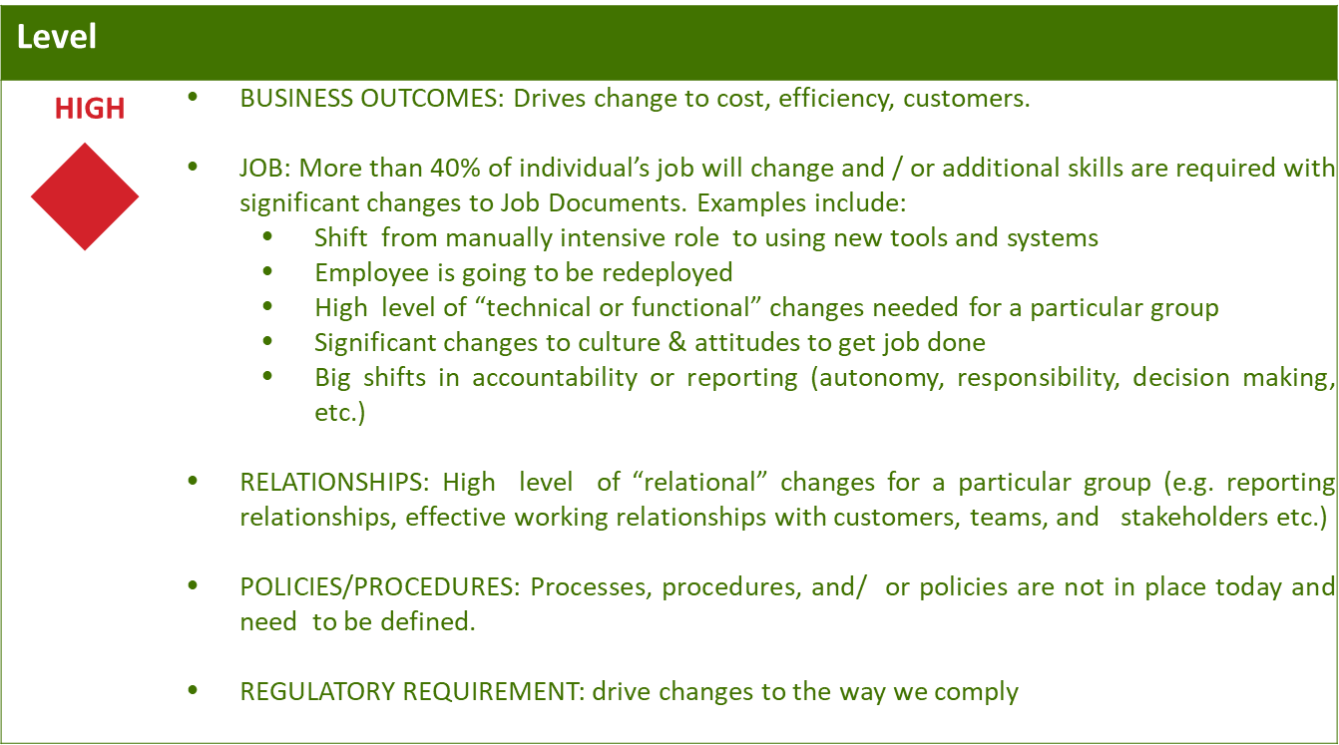
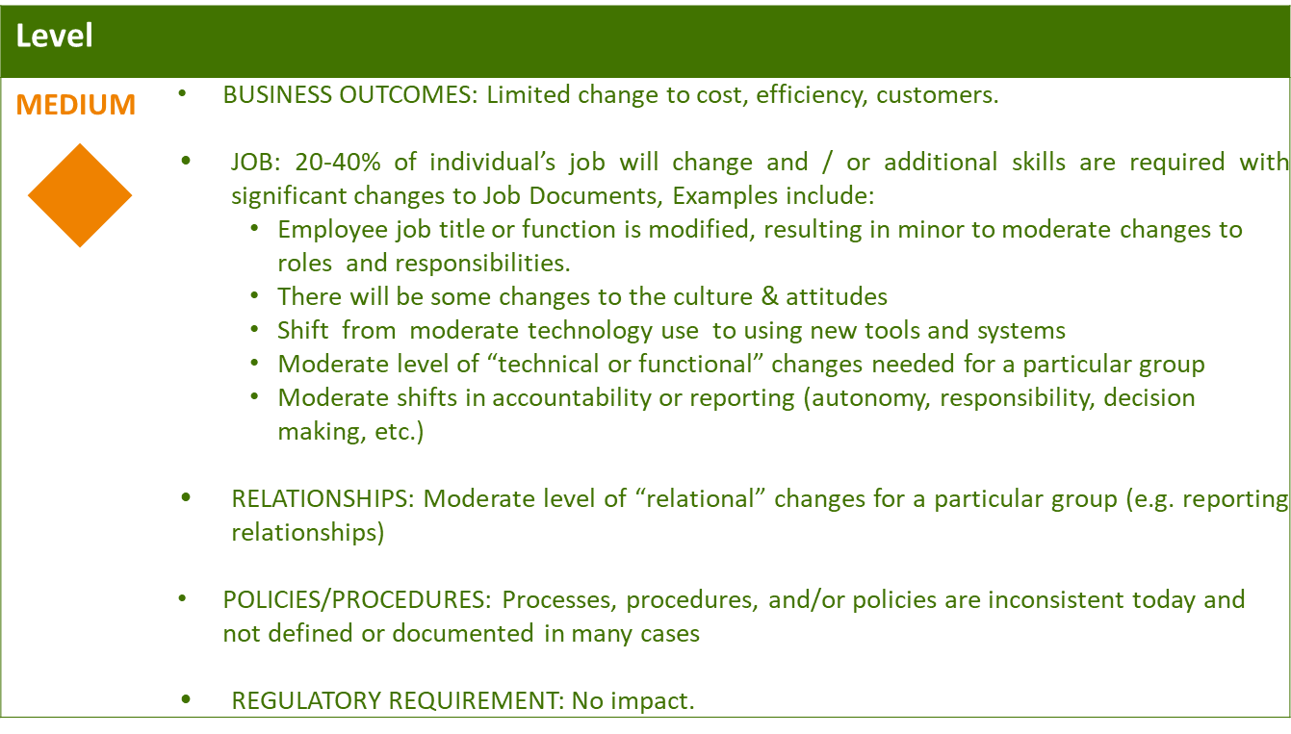
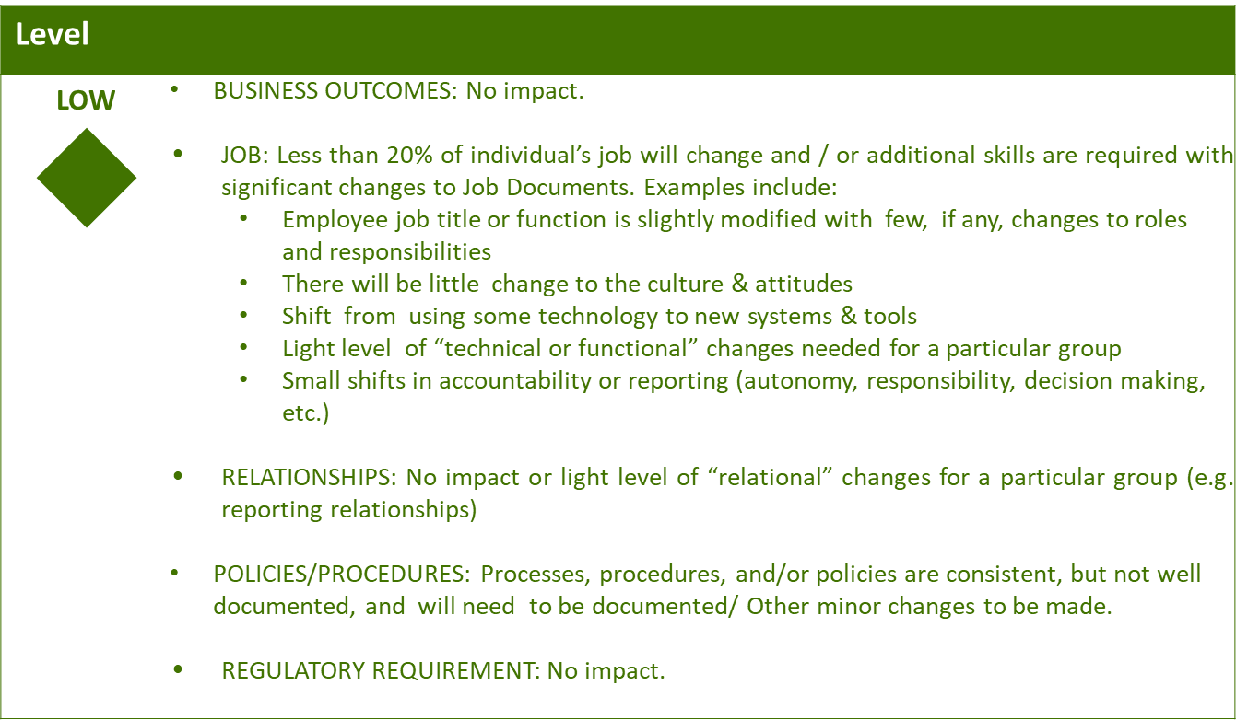

Business Effort: Initial assessment of the impact to the business High, Medium, Low

6. Requirements

7. Appendix

